g05-07-2019

**Prepared By**



t



**User Manual :Forest Rights Act**

Table of Contents

1. Introduction 3

1.1 Purpose 3

2. Citizen Module 3

2.1 Individual 5

2.2 Community 11

3. Gram Sabha Module 19

3.1 FRA Approval Gram Sabha 20

3.2 FRA Claim Request One Time 25

3.2.1 Individual 25

3.2.2 Community 33

3.3 User Registration for forest Right Act 40

4. Range Officer Module 41

5. Sub Divisional Officer 45

6. Divisional Forest officer 48

7. Tribal Area Development 52

8. Collector 56

# 

# Introduction

# 1.1 Purpose

This Help Document guides the intended Forest Right Act User how to manage and fill various FRA forms and complete the respective requirements.

# Citizen Module

1. Citizen First login into SSO by using SSO id and password.

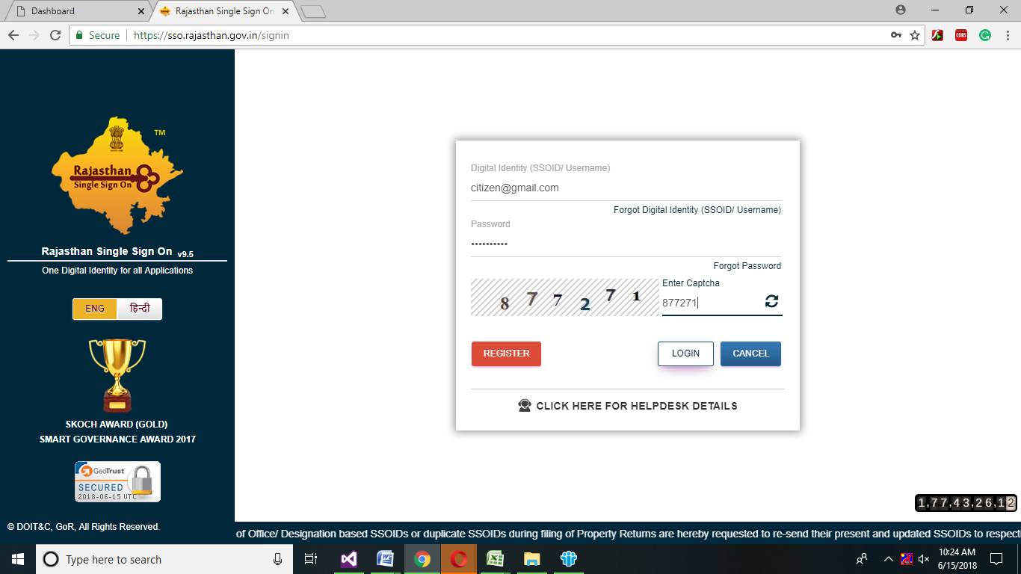

1. After login into SSO, Citizen Dashboard will open then citizen will click on Clearance and NCOs->Apply for forest Act.

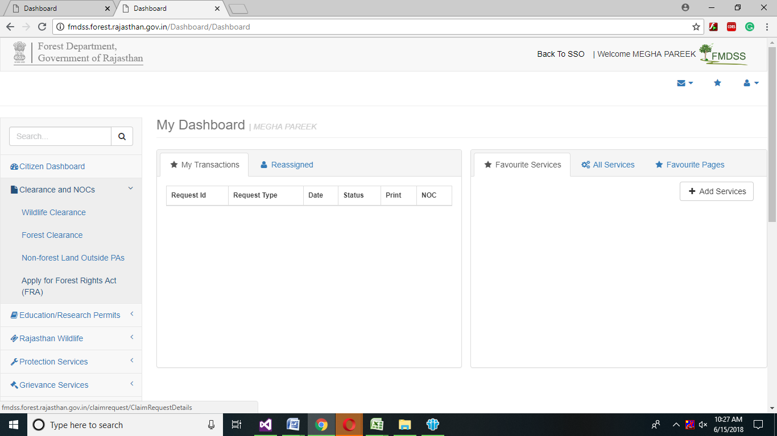

1. After clicking on Apply for Forest Act, Forest Right Act: Claim Form will open.

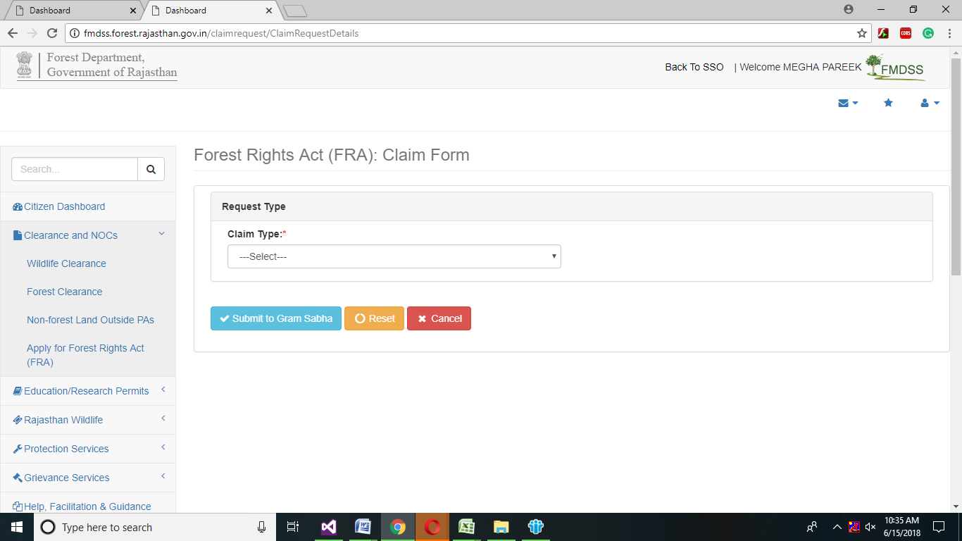

1. Citizen will select Claim Type from the drop down menu
2. After selecting claim type, Individual /Community form will open.

# Individual

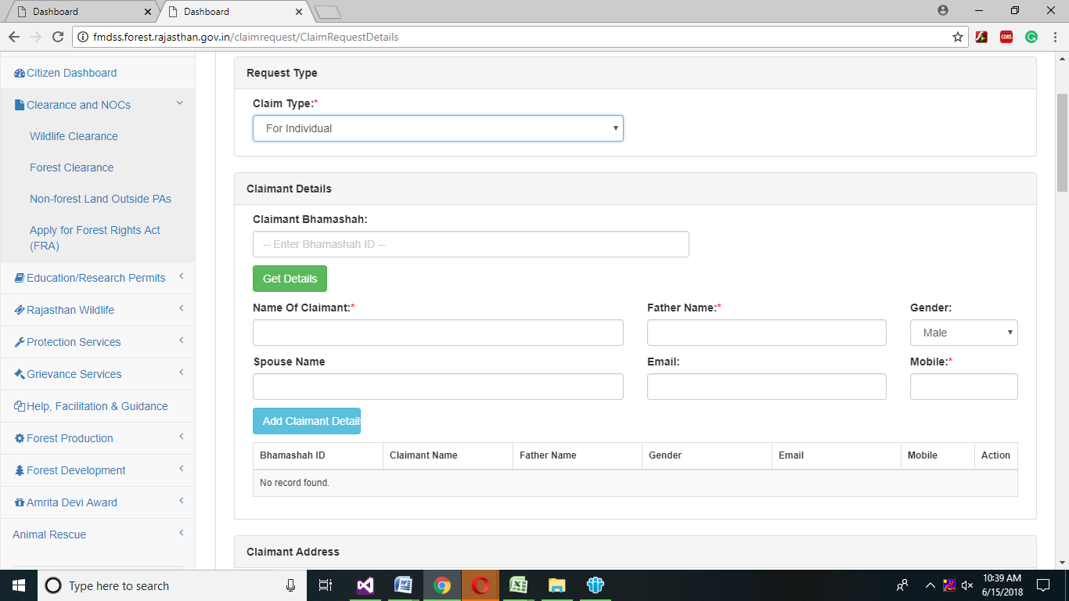

1. If Citizen selected Individual form, Then Citizen will enter Claimant Details in claimant Details grid Claimant Bhamashah id and then click on Get Details button.
2. After clicking on Add Claimant Details button, View member Details page will open, then citizen will select claimant by clicking on radio button, then member details will automatically generated in mandatory fields.

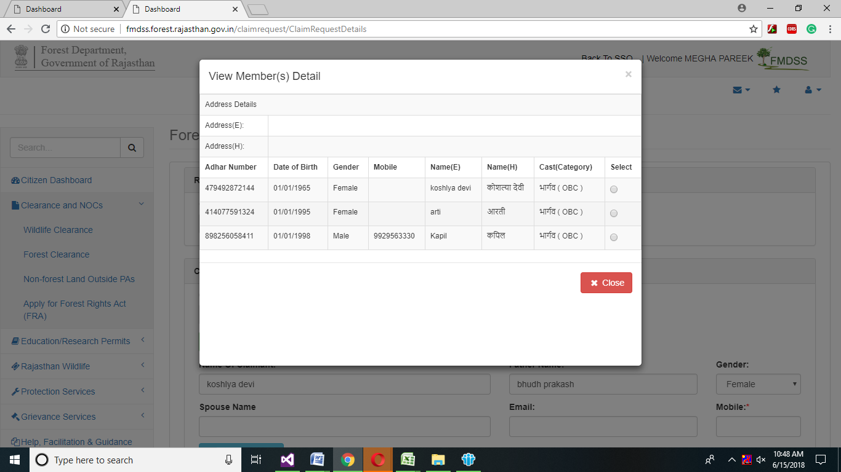

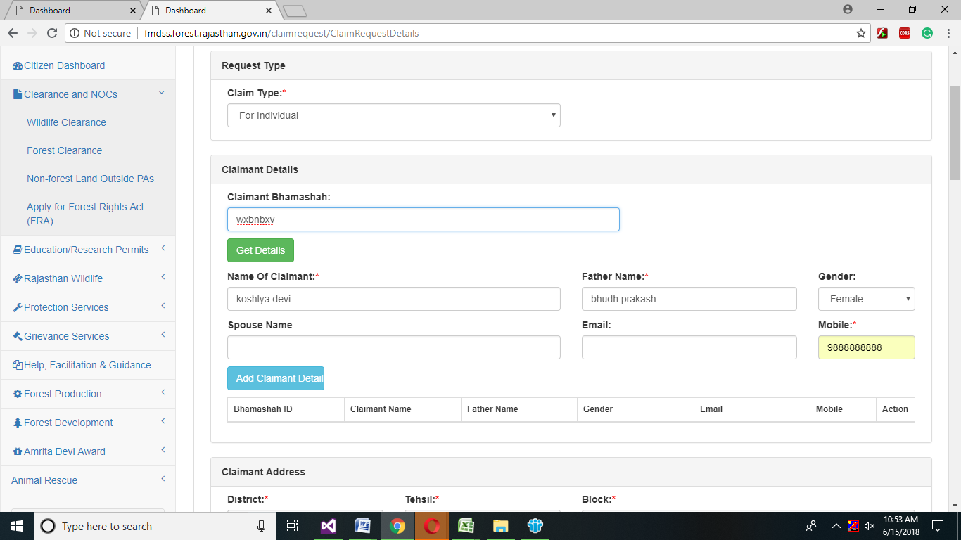

1. Claimant can enter Spouse Name and Email as per claimant choice and then click on Add Claimant Detail button.

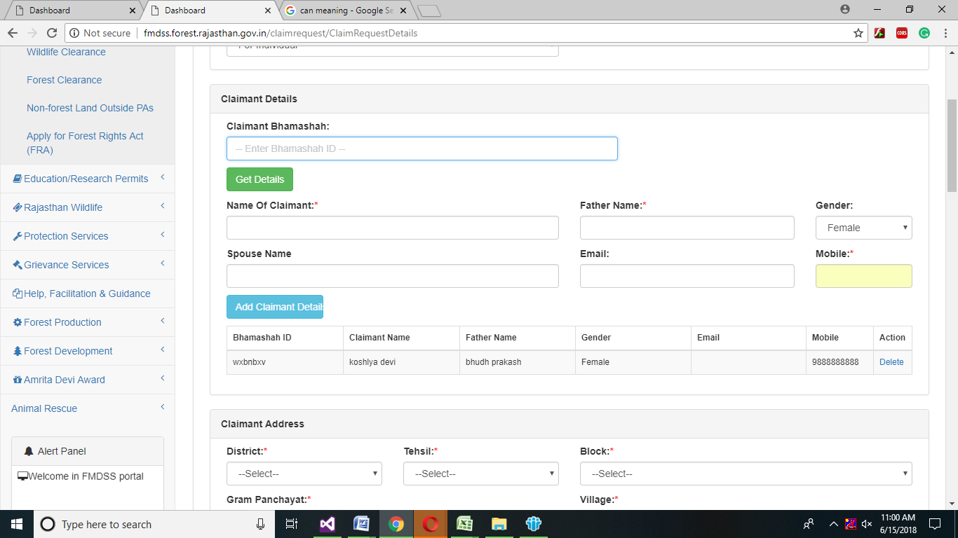

1. After click on Claimant Details button, Claimant details will automatically updated and claimant can delete the grid by clicking on delete.

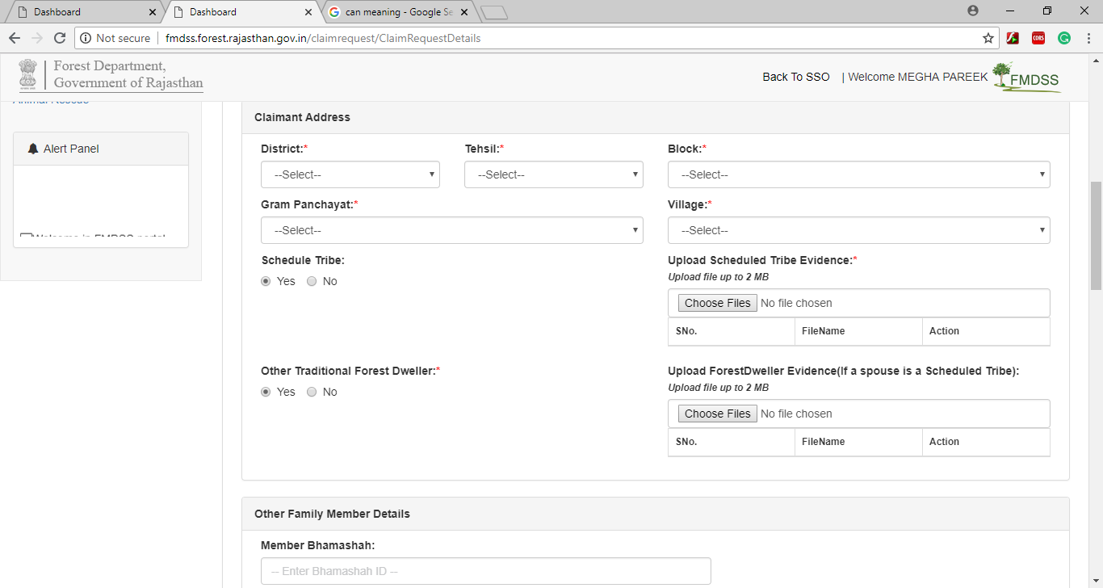

1. In Claimant Address grid, Claimant will select the mandatory drop down .Claimant will select Claimant District, Tehsil, Block, Gram Panchayat, and Village from the drop down menu.

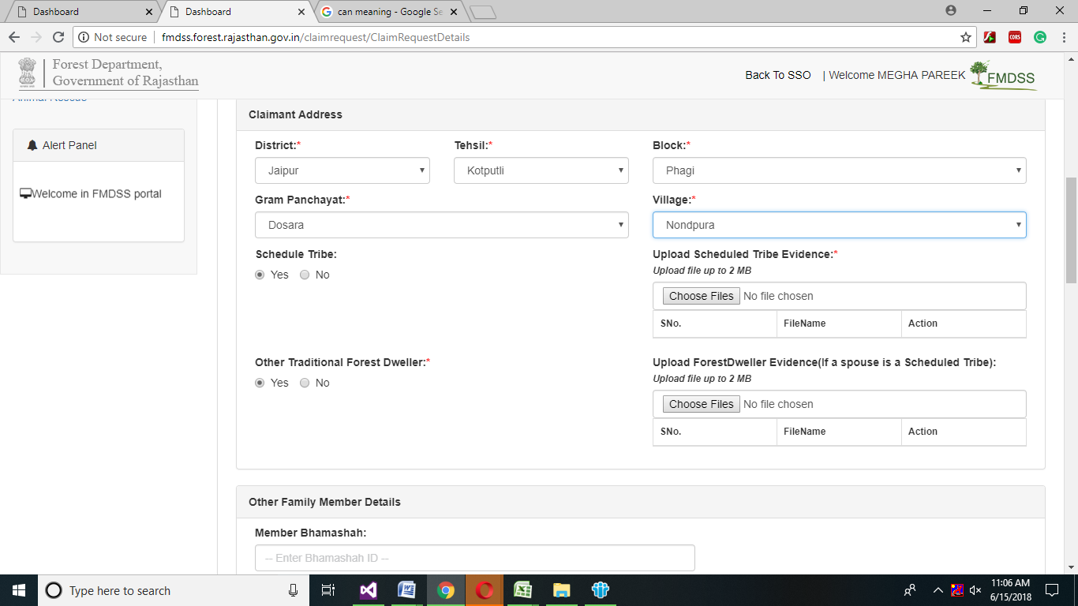

1. After selecting drop down menu, claimant will select yes radio button if claimant belongs to Schedule Tribe and Upload Scheduled Tribe Evidence by clicking on Choose File button.
2. If claimant belong to Other Traditional forest Dweller, then click on yes radio button and upload the evidence only if Claimant Spouse is a Scheduled Tribe.

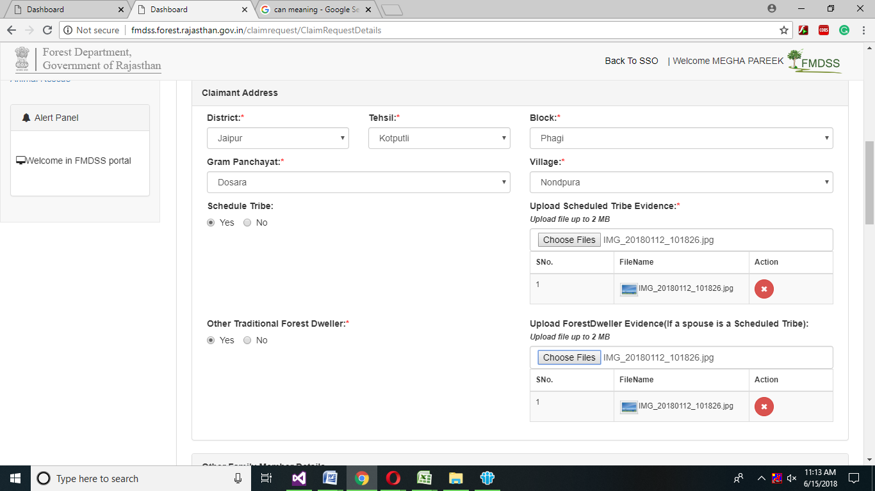

1. Claimant will enter other family details in other family Member Details grid, claimant will enter Bhamashah id and then click on Get Details button.

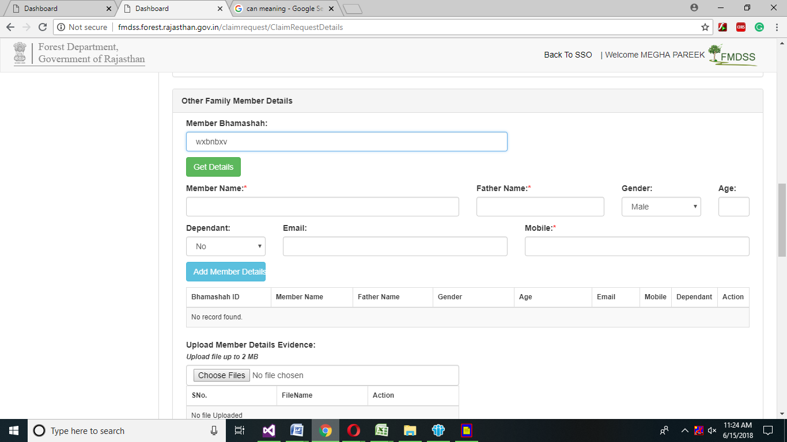

1. Claimant will select the Claimant Family member and click on radio button, Claimant family member information will automatically generated in mandatory fields.



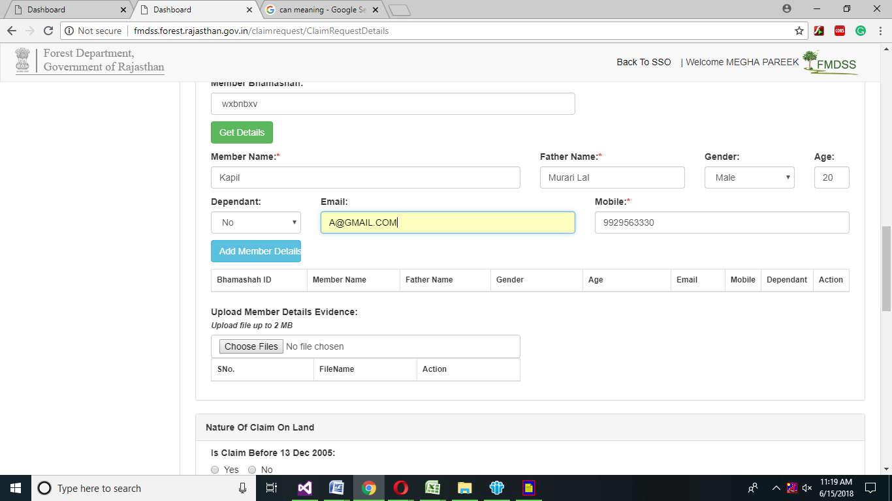

1. Claimant will click on Add member details button, then member details will automatically generated in grid and upload claimant family member evidence by clicking on choose button.

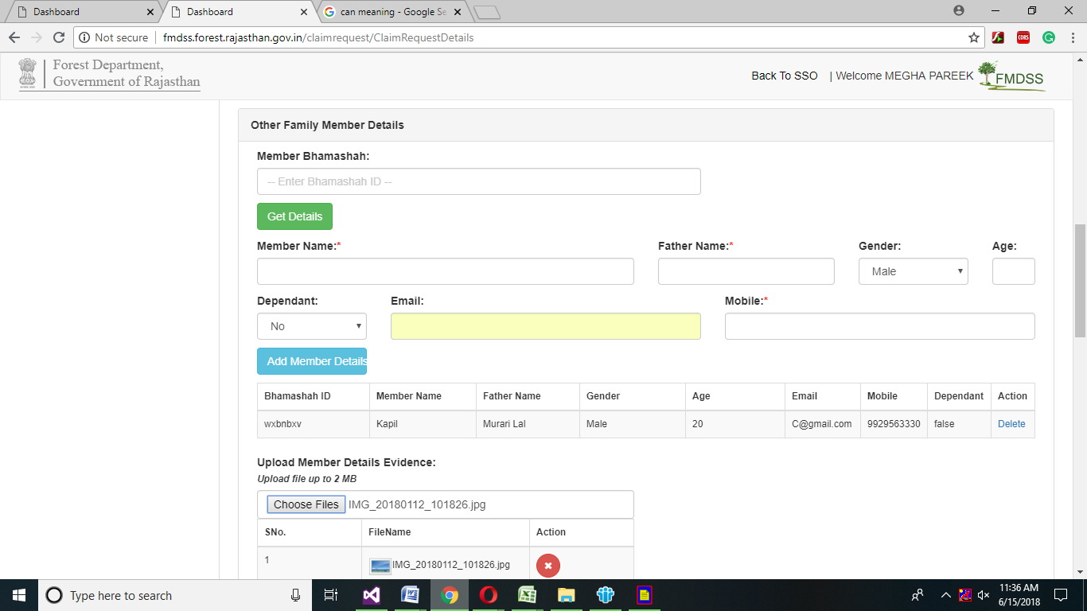

1. If Claimant is done before 13 Dec 2005 ,then claimant will select yes radio button otherwise no.

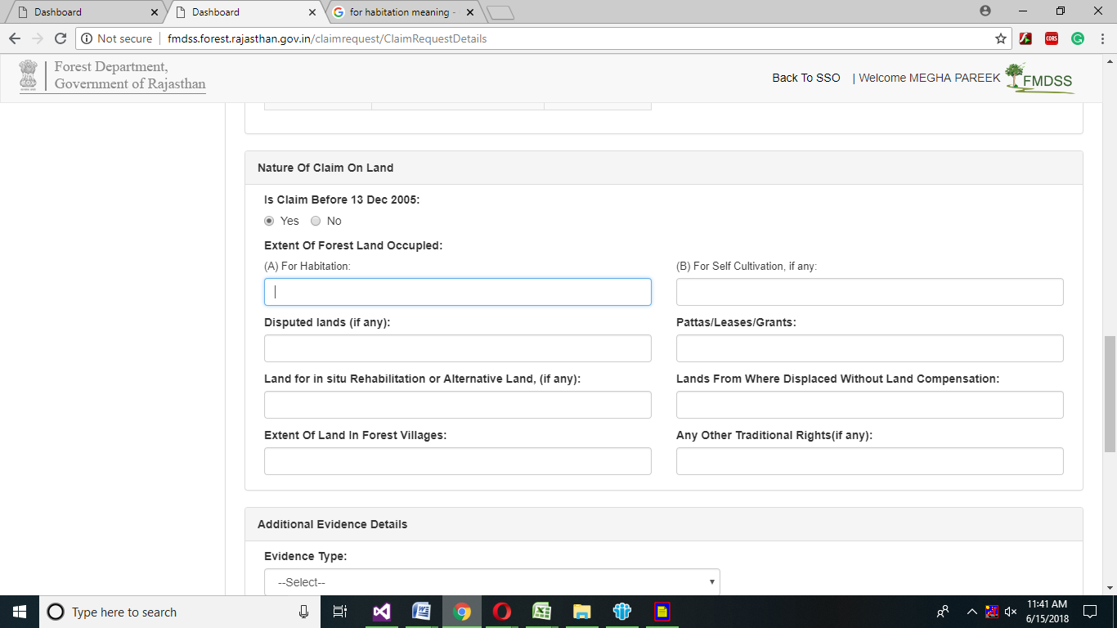

1. Claimant will enter in Extent of Forest Land Occupied grid, Claimant will enter in Highlighted field, if claimant have any of highlighted field forest occupied land.

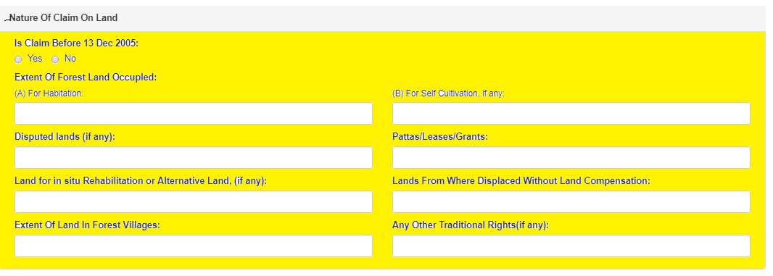

1. In Additional Evidence Details grid, claimant select the evidence type from the drop down menu and upload the selected evidence by clicking on choose files button.

Note: Uploading Files Must be up to 2Mb

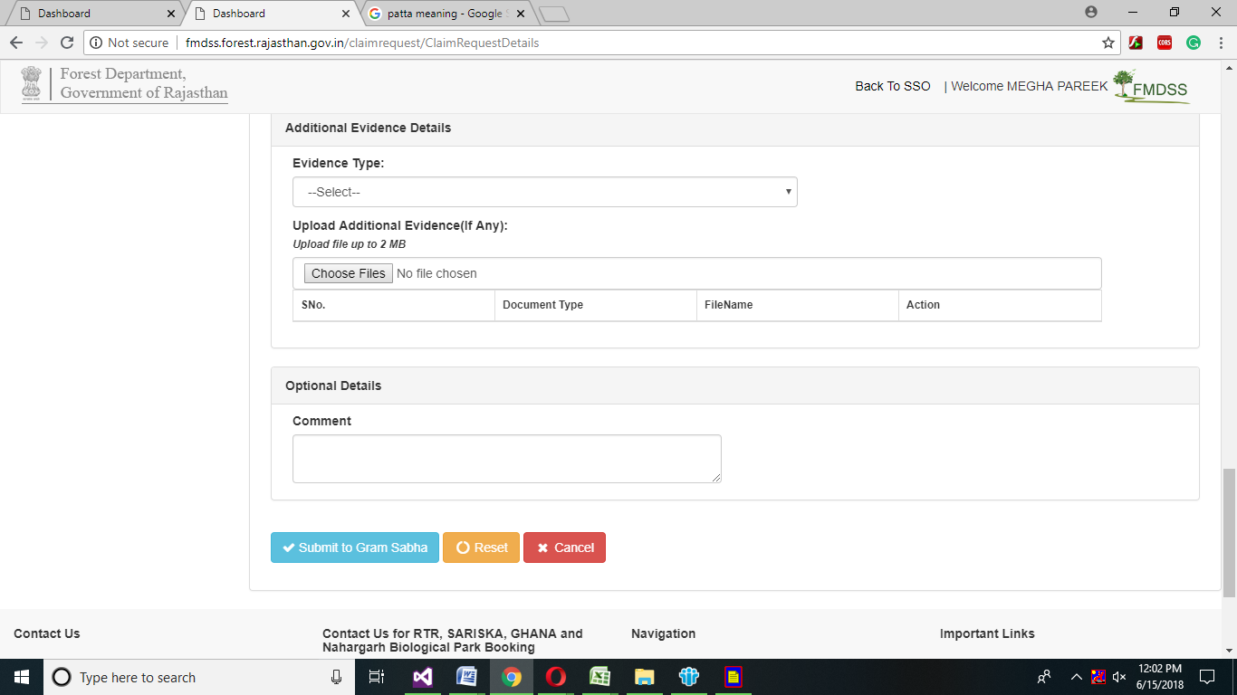

1. After Uploading Additional Evidence, claimant can enter optional details in Comment Text box and then click on Submit to Gram Sabha button.
2. If claimant want to reset the form click on Reset button
3. If claimant want to cancel the form click on cancel button

# Community

1. Claimant will select the claimant type community from the drop down menu.

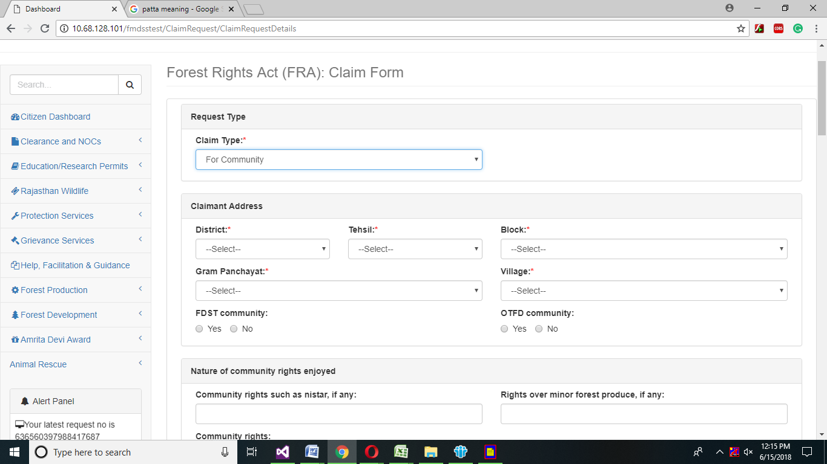

1. Claimant will enter Claimant address in Claimant address grid.

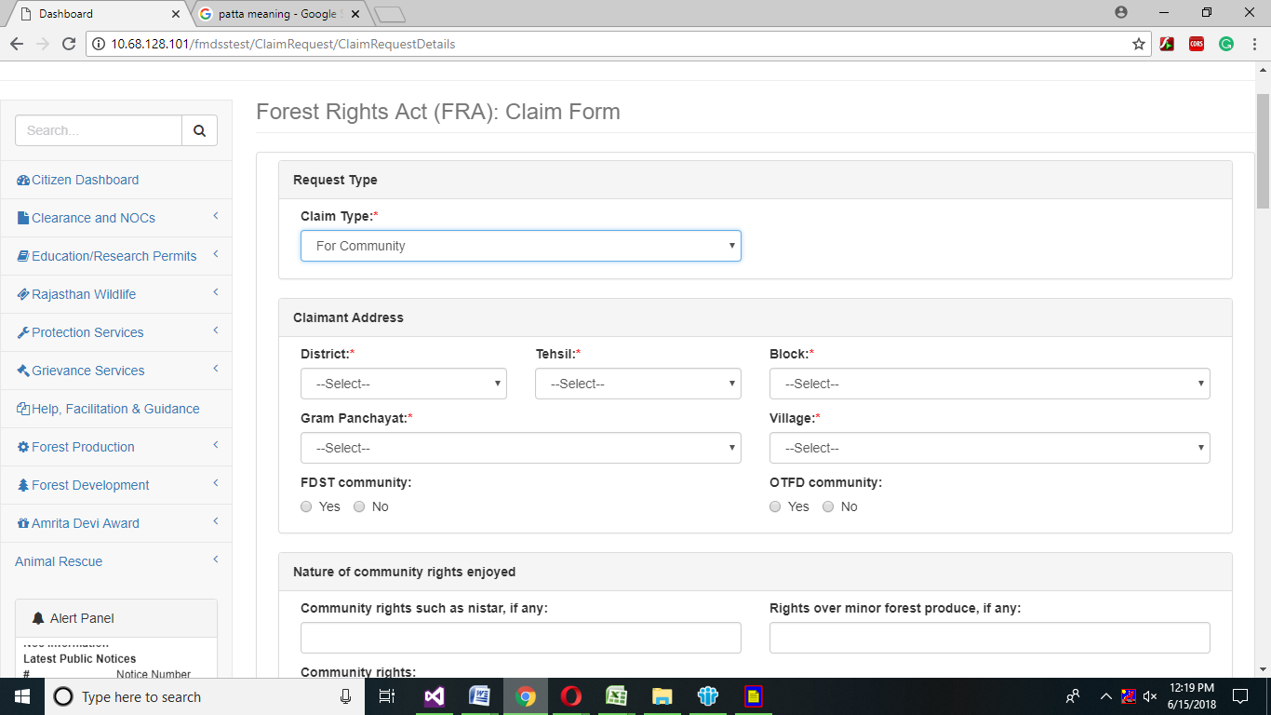

1. In Claimant Address grid ,claimant will select the mandatory drop down
2. Claimant will select Claimant District, Tehsil, Block, Gram Panchayat, and Village from the drop down menu.
3. If Claimant belongs to FDST Community then click on yes otherwise no similarly if claimant belong to OTFD Community click on yes otherwise no.

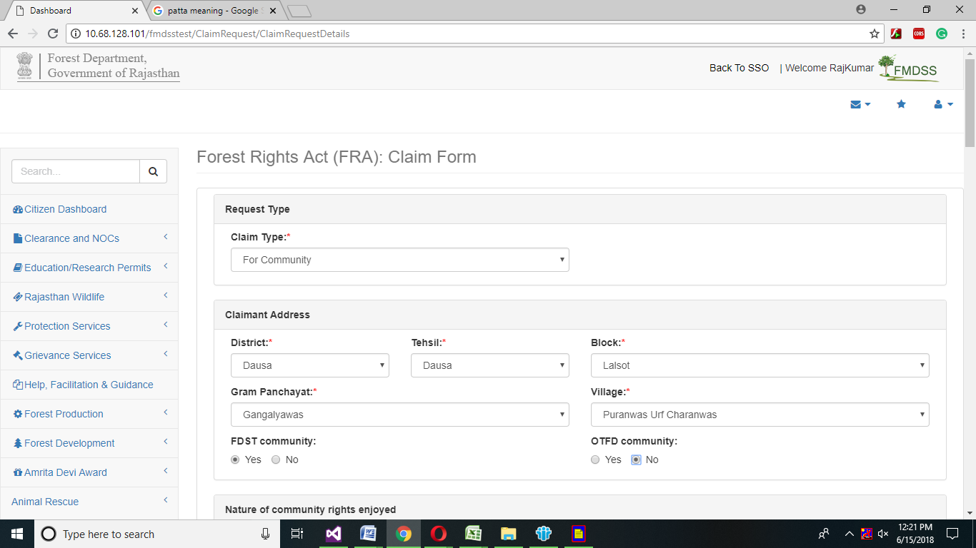

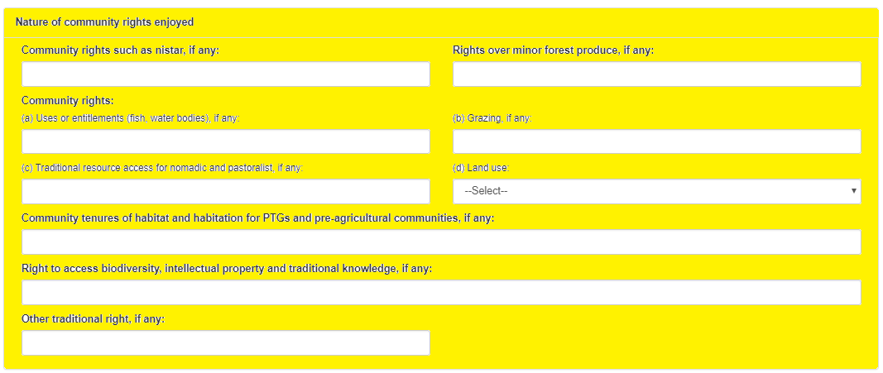

1. In Nature of Right and Community grid, if claimants have any above community rights, then claimant will enter will above highlighted field.

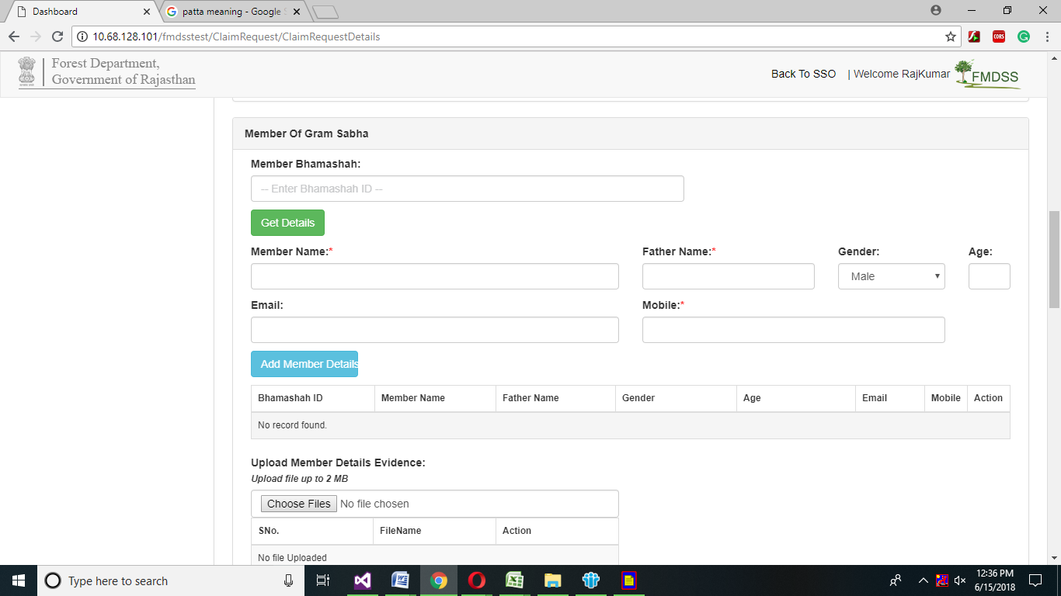

1. In Member of Gram Sabha grid, Claimant will enter Member Bhamashah id in member Bhamashah field and then click on Get Details button.

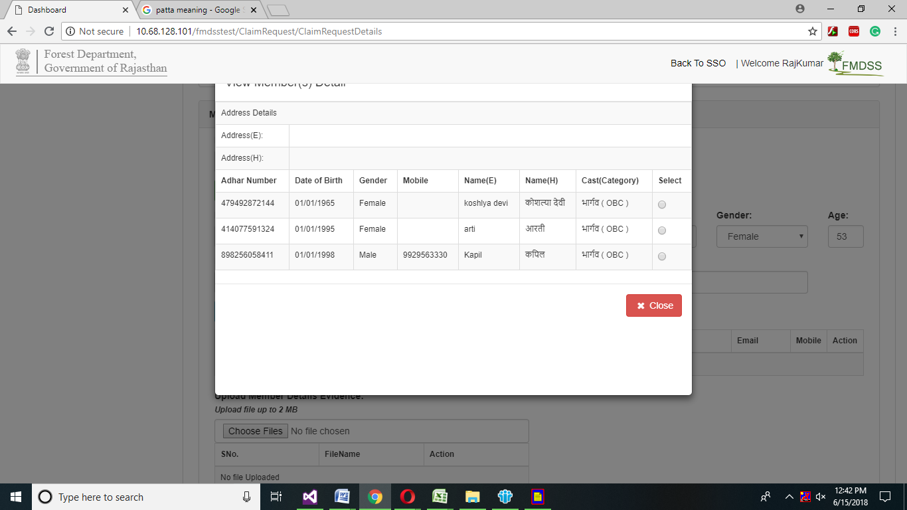

1. Claimant will select the Claimant member and click on Radio button, Claimant family member information will automatically generated in mandatory fields
2. Claimant will click on Add Claimant details button , then claimant details will automatically generated in grid as shown in belong highlighted screenshot.

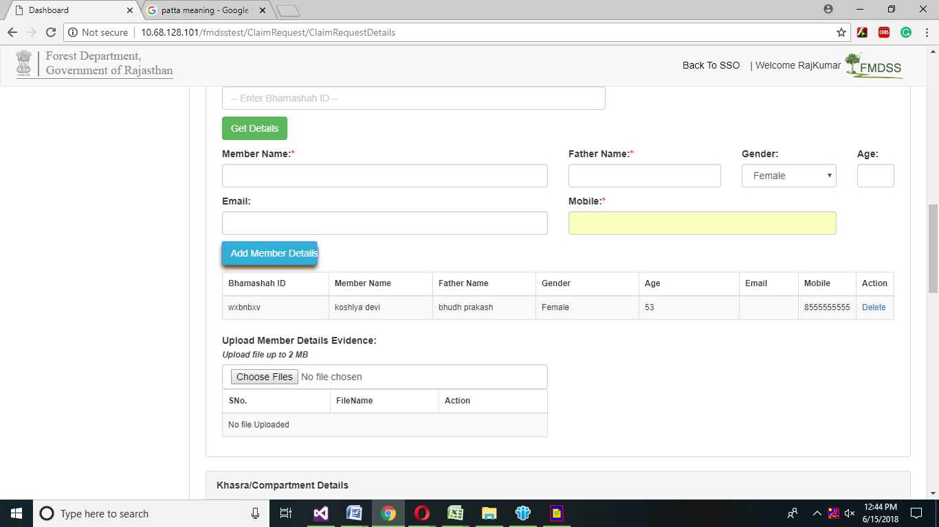

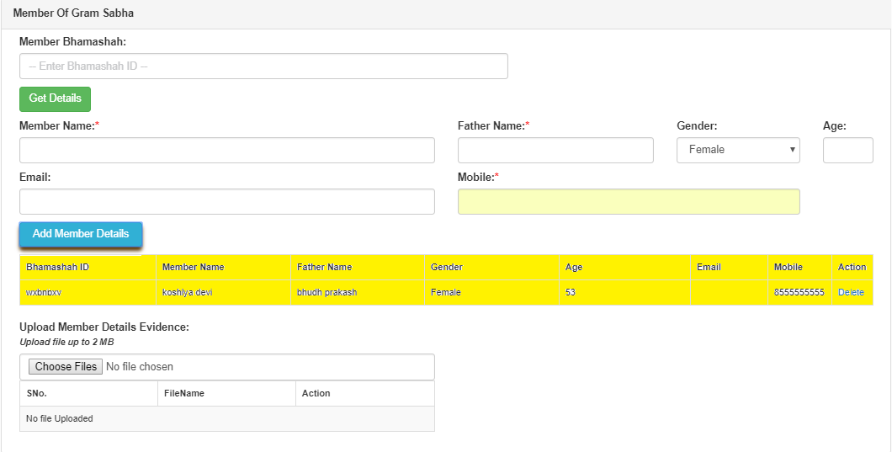

1. Claimant will upload claimant member details evidence by clicking on choose button.

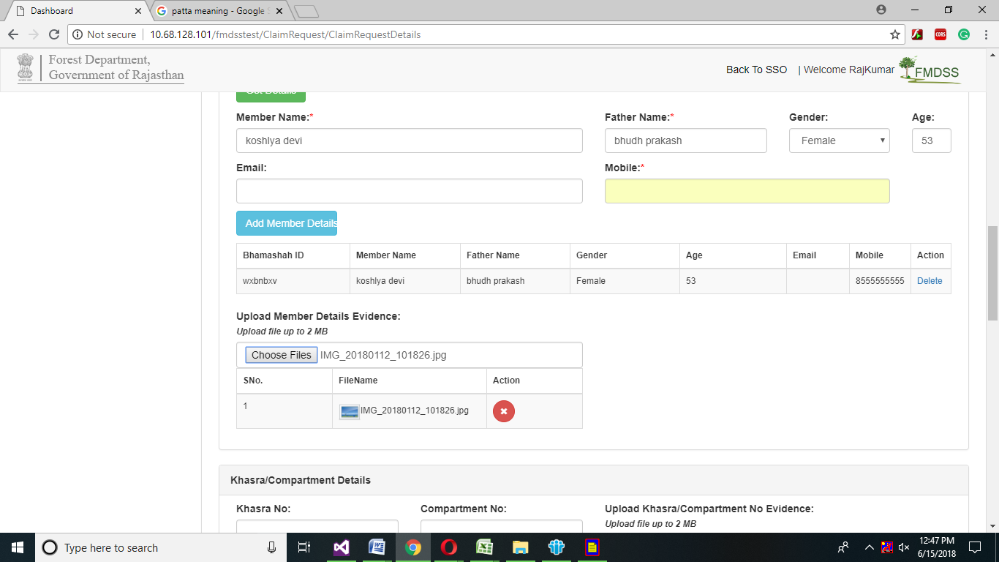

1. Claimant will enter Khasra No, Compartment No and Upload khasra/Compartment No evidence by clicking on choose button.

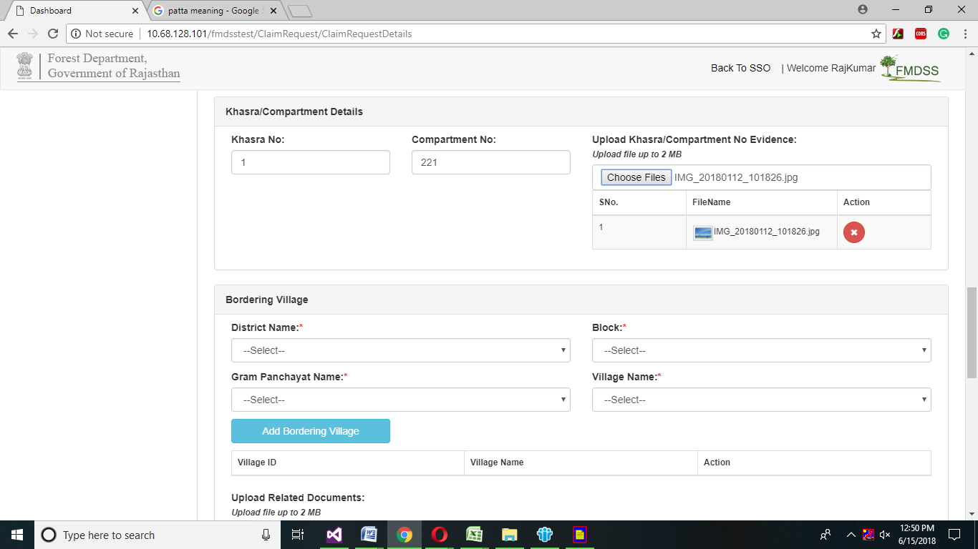

1. In bordering Village grid Claimant will select highlighted mandatory fields from the drop down menu.
2. Then click on Add Bordering Village button all the Bordering village information will automatically generated in grid and then upload related documents by clicking on Choose Files button.

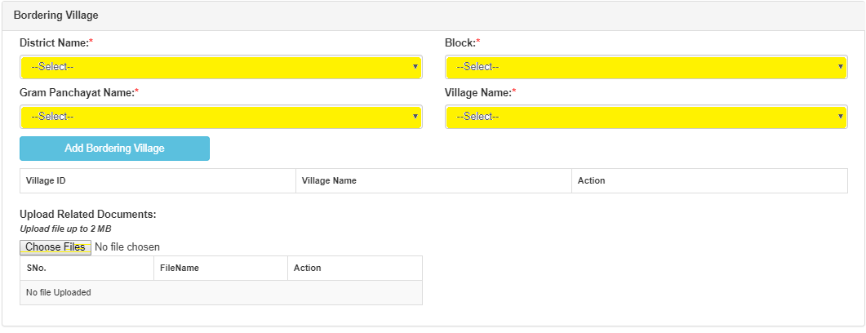

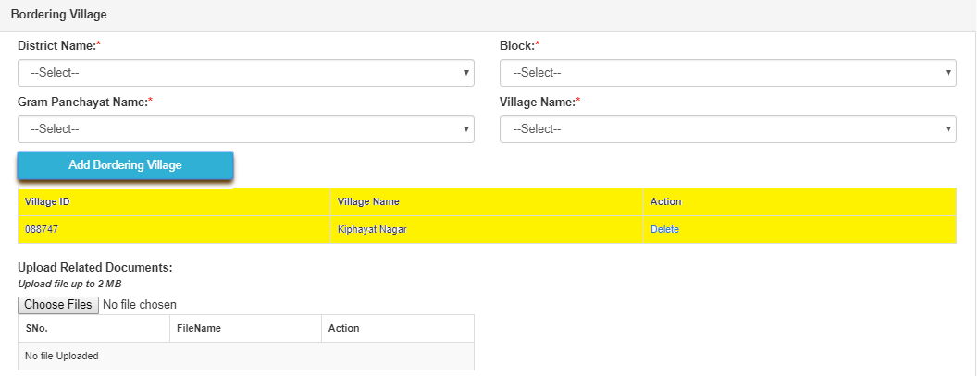

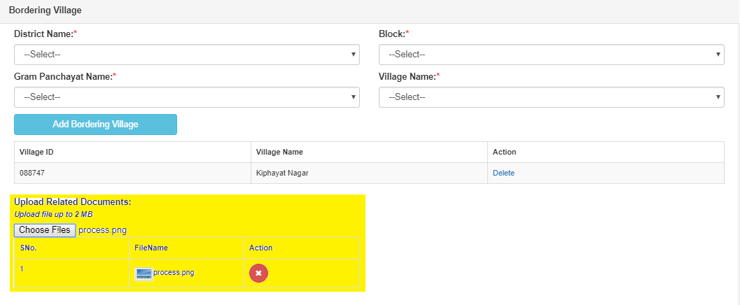

1. In Additional Evidence Details grid ,claimant will select evidence type from the drop down menu and then selected evidence type claimant will upload by clicking on choose button.

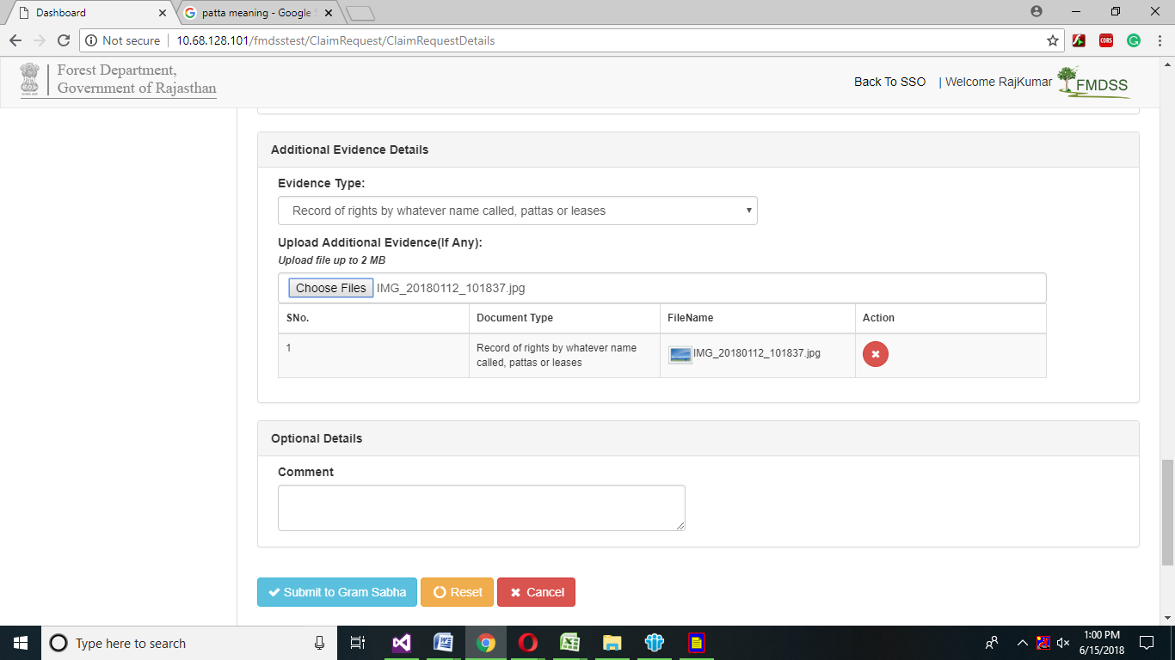

1. In optional Details grid, claimant can enter comment in comment text box and click on Submit to Gram Sabha button.
2. Claimant can reset the form by clicking on reset button.
3. Claimant can cancel the form by clicking cancel button.

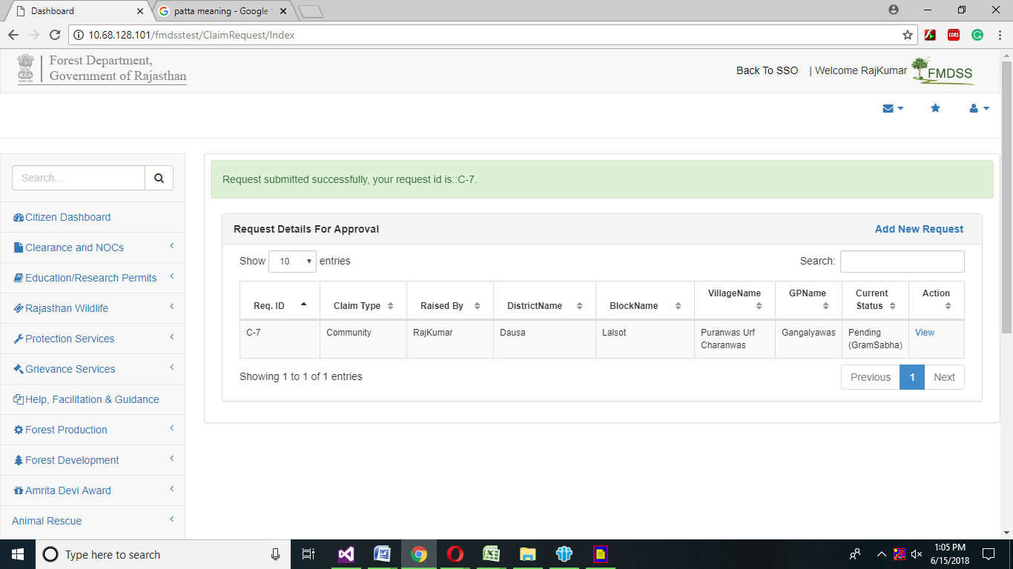

XVI. After clicking on Submit Gram Sabha button, Claimant request will successfully submitted and show in Request Details for Approval grid, claimant want to apply for more request then click on Add New Request button.

# Gram Sabha Module

1. Gram Sabha user will login in SSO using SSO id and password.

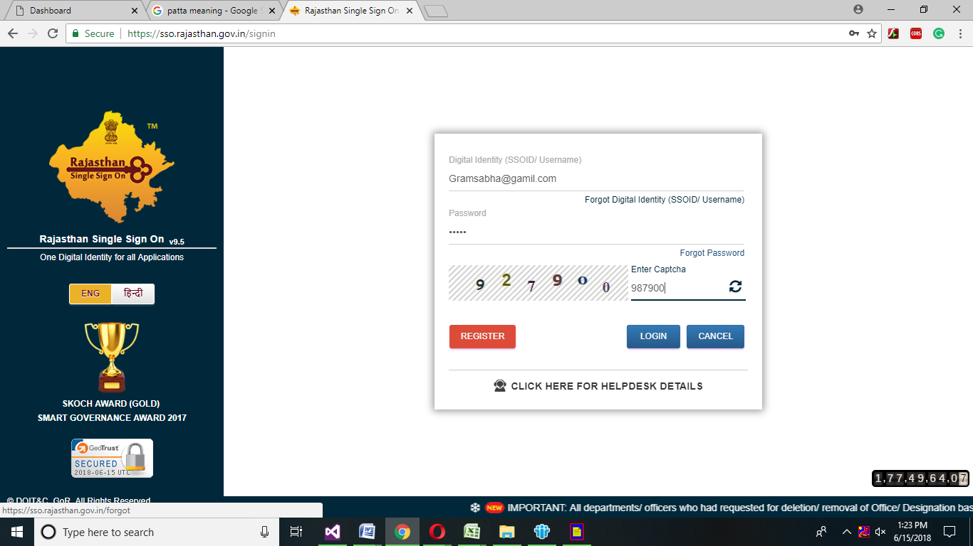

1. Gram Sabha user dashboard will open, click on FRA in forest development.

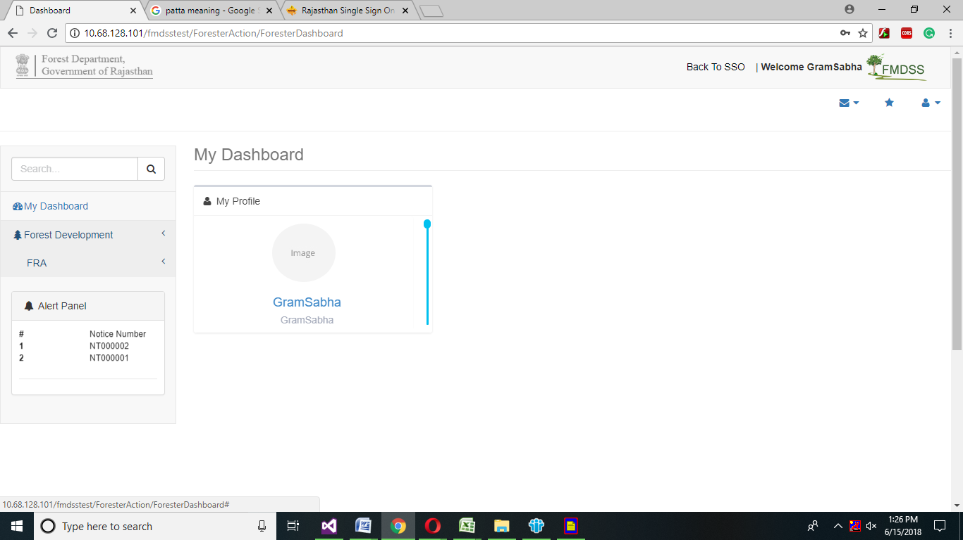

# 3.1 FRA Approval Gram Sabha

1. Click on FRA approval gram Sabha.

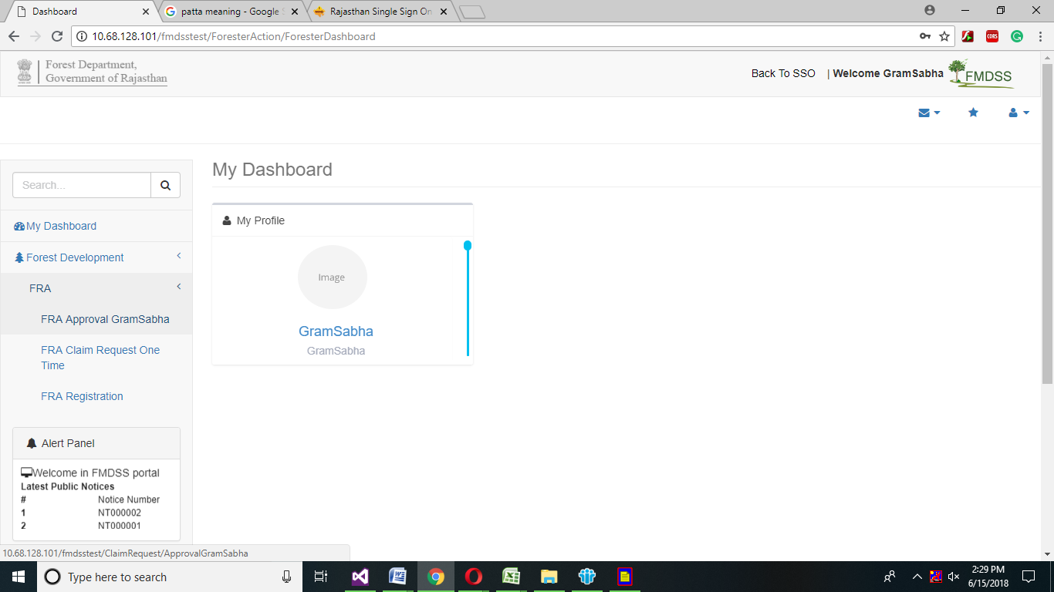

1. Click on Add survey details in Action grid.

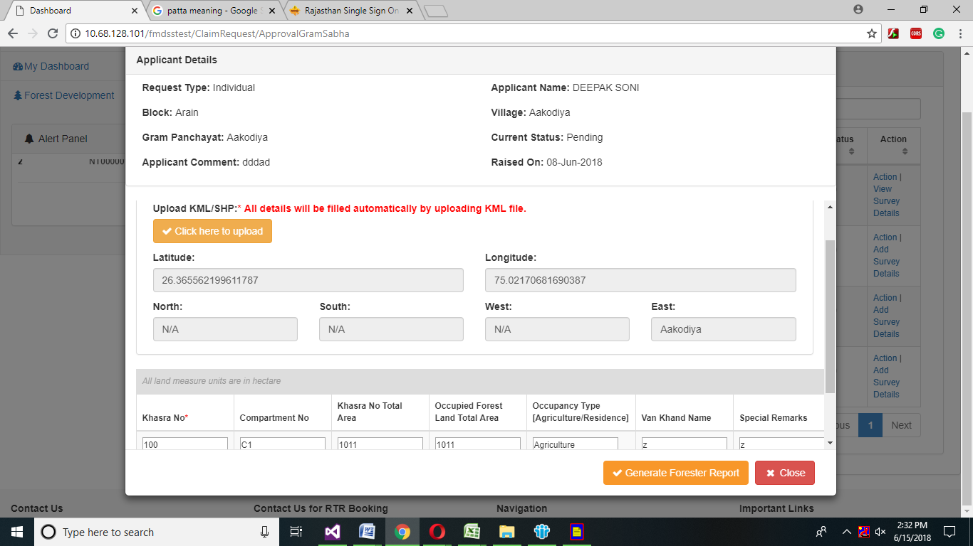

1. Then click on Click here upload button.

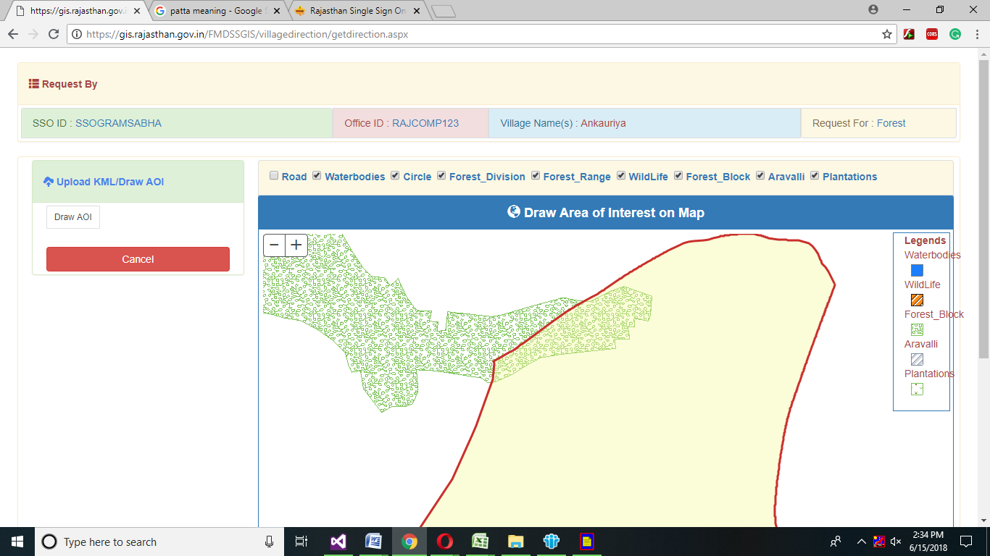

1. Click on Draw AOI and draw area of interest on Map.

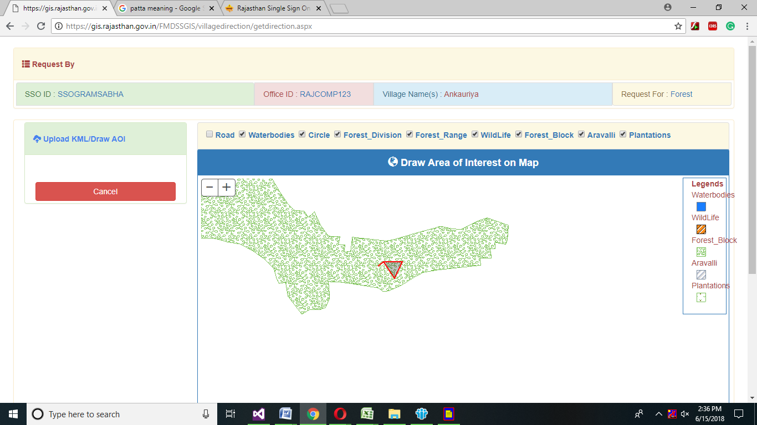

1. Select Direction from the direction drop down menu.

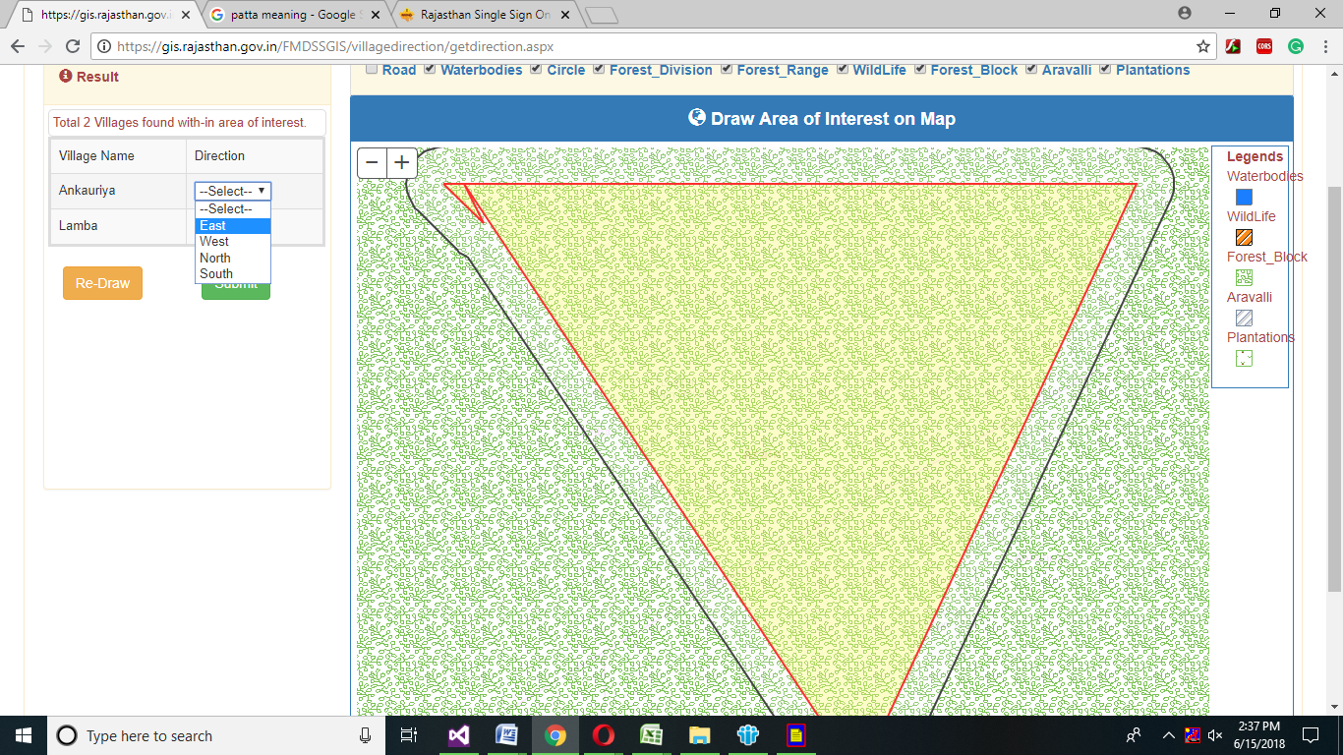

1. After selecting direction, click on submit button.

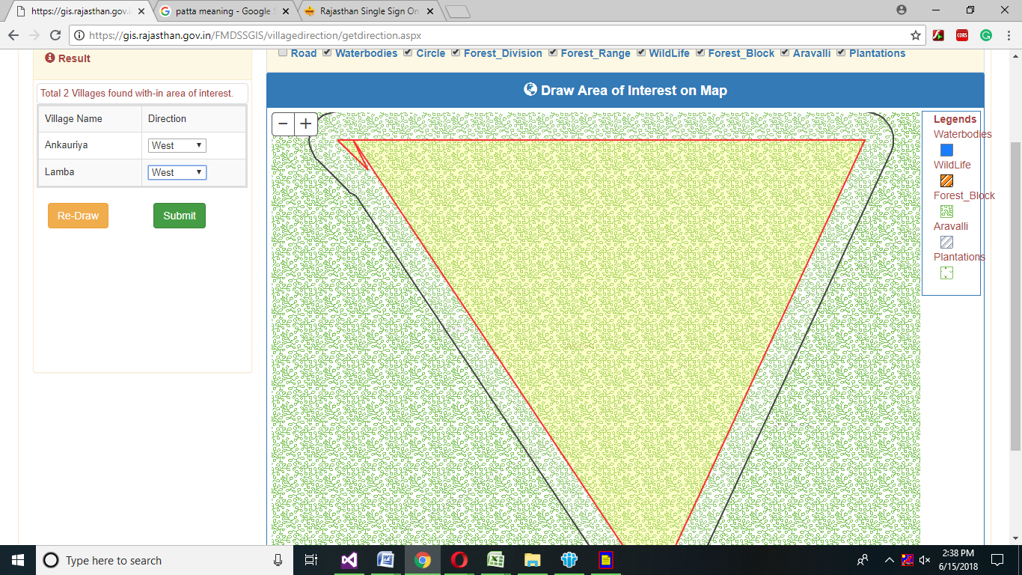

1. All the information will generate automatically after clicking on submit button, then click on generate Forester Report button.

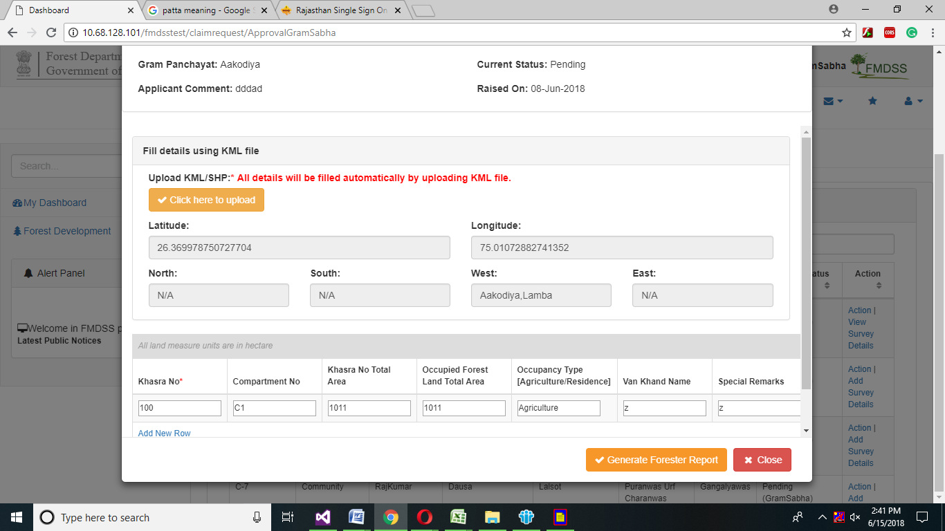

1. Enter valid OPT number from your valid mobile number and click on Continue button.

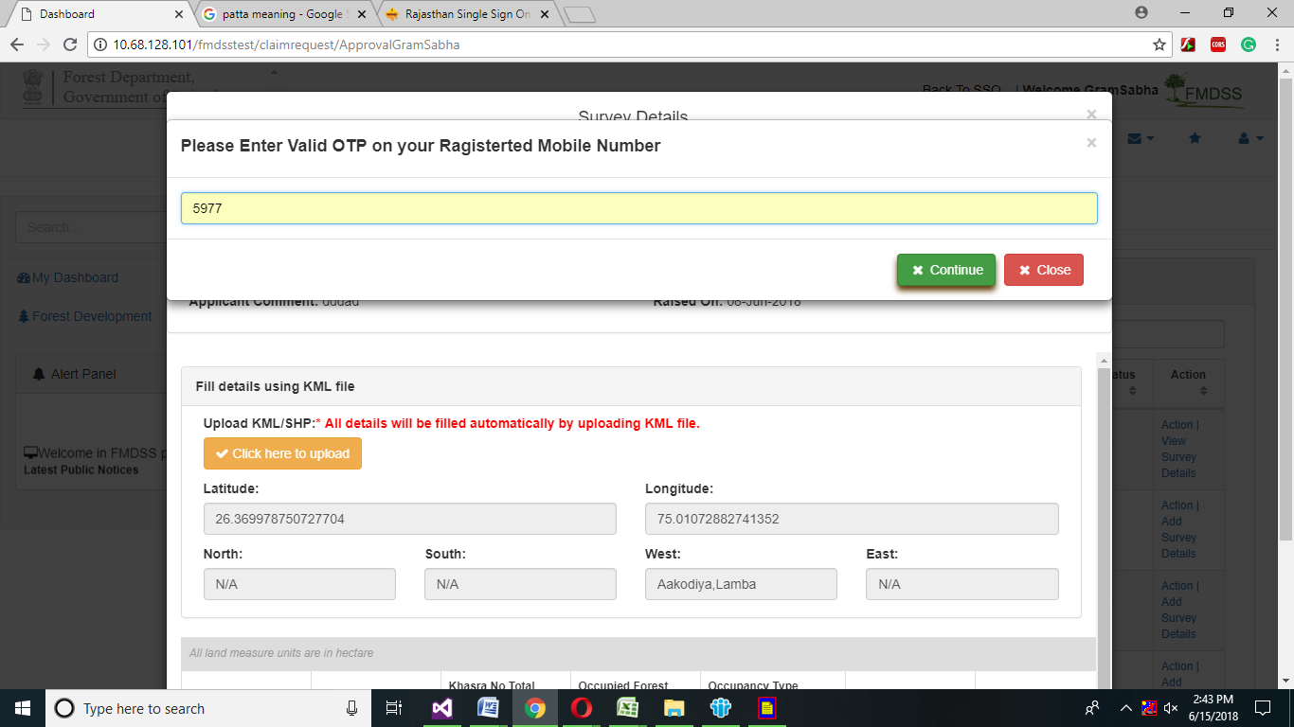

1. Click on Action button.

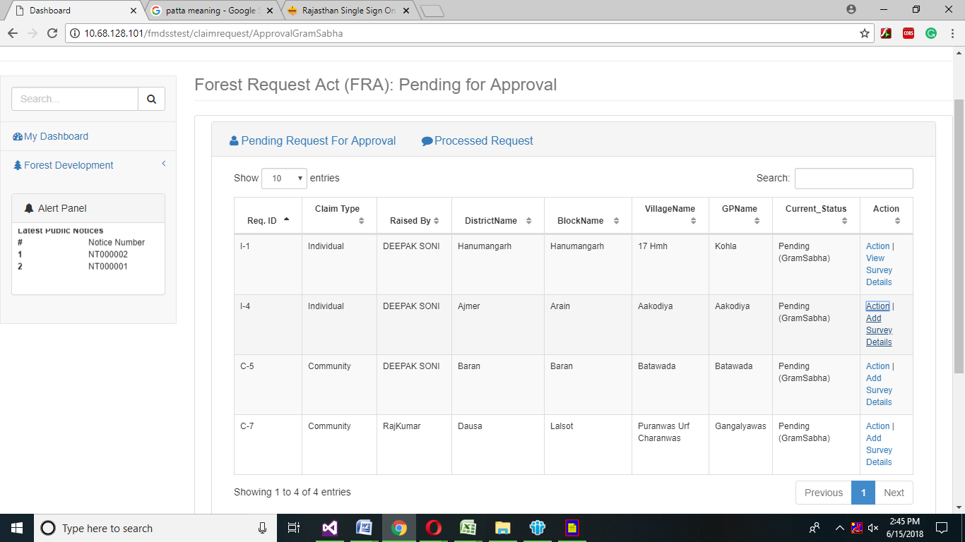

1. If Gram Sabha officer have any documents then gram Sabha officer can upload gram Sabha related documents by clicking on click here upload files link.
2. Enter FRC Remark and select action from the drop down menu as per the request of citizen and click on yes, if Forester and patwari report available otherwise click on no radio button.

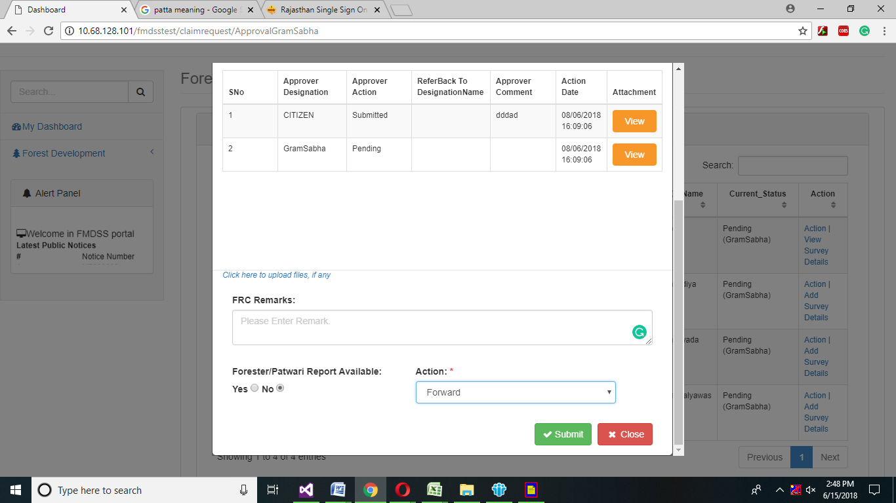

1. If Gram Sabha officer wants to reassign the request of citizen, then select reassign from the drop down menu.
2. If Gram Sabha wants to reject the request of citizen, then select the reject option from the drop down menu.
3. After selecting reject option from the drop down action then reason drop down menu will appear, Gram Sabha officer will select reason why gram Sabha officer want to reject the request of citizen.
4. After selecting appropriate reason, Click on submit button.

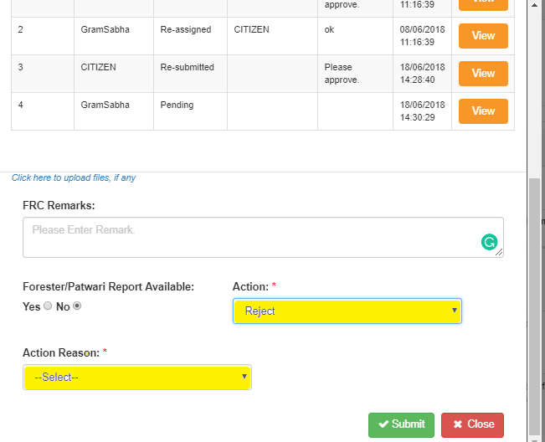

# 3.2 FRA Claim Request One Time

(Gram Sabha office can enter old record in the system using claim form which are not entered yet)

# 3.2.1 Individual

1. Click on FRA claim Request one time.(Individual)

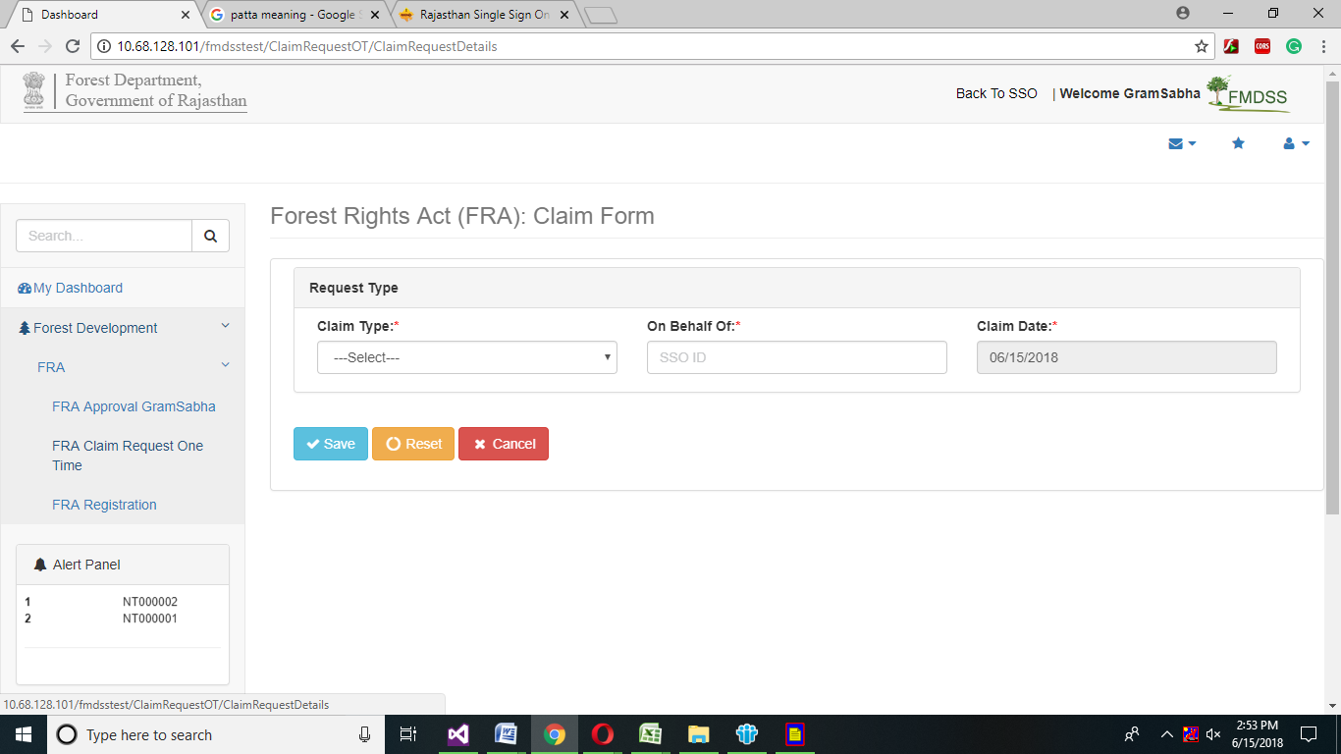

1. In Request Type grid select Claim Type, enter SSO id in on Behalf of field and select Claim Date.
2. If Gram Sabha user selected Individual form, then Gram Sabha user will enter Claimant Details in claimant Details grid, Claimant Bhamashah id and then click on Get Details button.
3. After clicking on Add Claimant Details button, View member Details page will open then citizen will select claimant by clicking on radio button then member details will automatically generated in mandatory fields.





1. Gram Sabha user can enter claimant Spouse Name and Email as per claimant choice and then click on Add Claimant Detail button.



1. After click on Claimant Details button, claimant details will automatically updated and Gram Sabha user can delete the grid by clicking on delete.



1. In Claimant Address grid, Gram Sabha user will select the mandatory drop down. Gram Sabha user will select Claimant District, Tehsil, Block, Gram Panchayat, and Village from the drop down menu.



1. After selecting drop down menu, Gram Sabha user will select Yes Radio button if claimant belongs to Schedule Tribe and Upload Scheduled Tribe Evidence by clicking on Choose File button.
2. If claimant belongs to Other Traditional forest Dweller then click on yes radio button and upload the evidence only if Claimant Spouse is a Scheduled Tribe.



1. Gram Sabha user will enter other family details in other family Member Details grid; claimant will enter Bhamashah id and then click on Get Details button.



1. Gram Sabha user will select the Claimant Family member and click on Radio button, Claimant family member information will automatically generated in mandatory fields.





1. Gram Sabha user will click on Add member details button, then member details will automatically generated in grid and upload claimant family member evidence by clicking on choose button.



1. If Claimant is done before 13 Dec 2005, then claimant will select yes radio button otherwise no.



1. Claimant will enter in Extent of Forest Land Occupied grid, Claimant will enter in Highlighted field, if claimant have any of highlighted field forest occupied land.



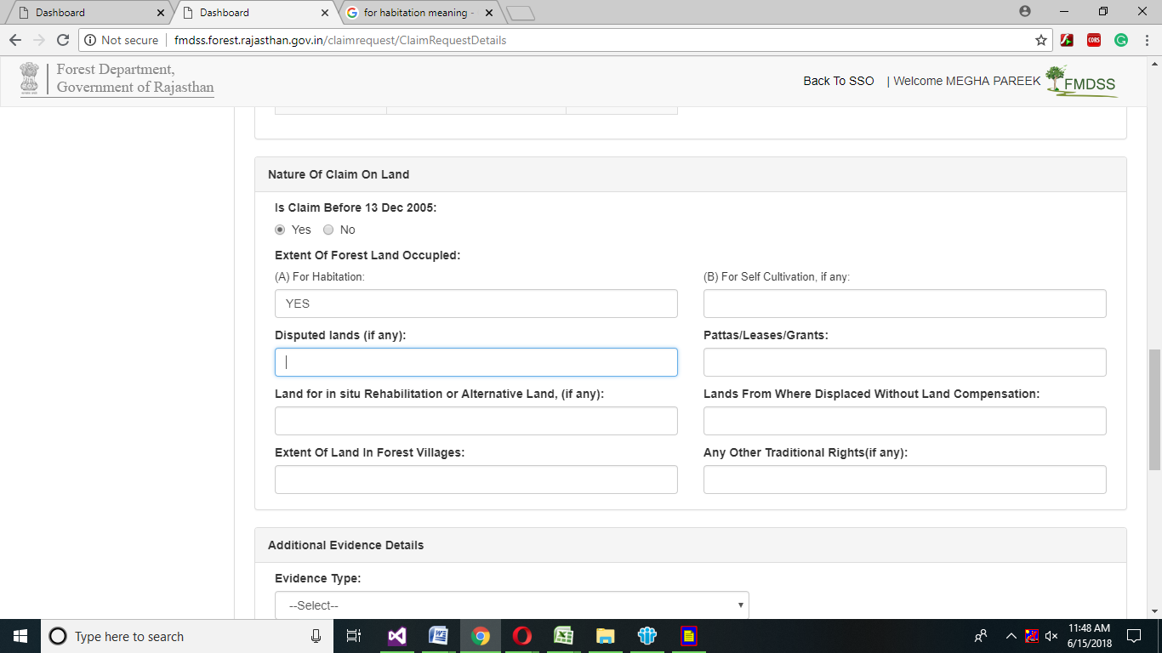

1. After Nature of Details, Gram Sabha user will select additional Evidence Details from Evidence type drop down menu and upload the selected evidence type by clicking on choose button.

Note: Evidence must be up to 2MB



1. After Uploading Additional Evidence, Claimant can enter Optional Details in Comment Text box.
2. In Approver Action, Approver user will enter Approver id of respected officer in text box and also enter Approval Date and Comment and Case Number in given fields.

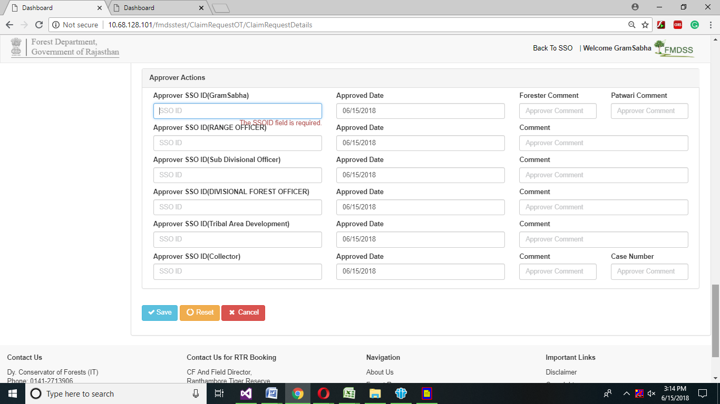

1. After entering all the necessary information, click on save button.
2. If Approver want to reset the form click on reset button.
3. If Approver want to cancel the form click on cancel button.

# 3.2.2 Community

1. Gram Sabha user will select claim type community.

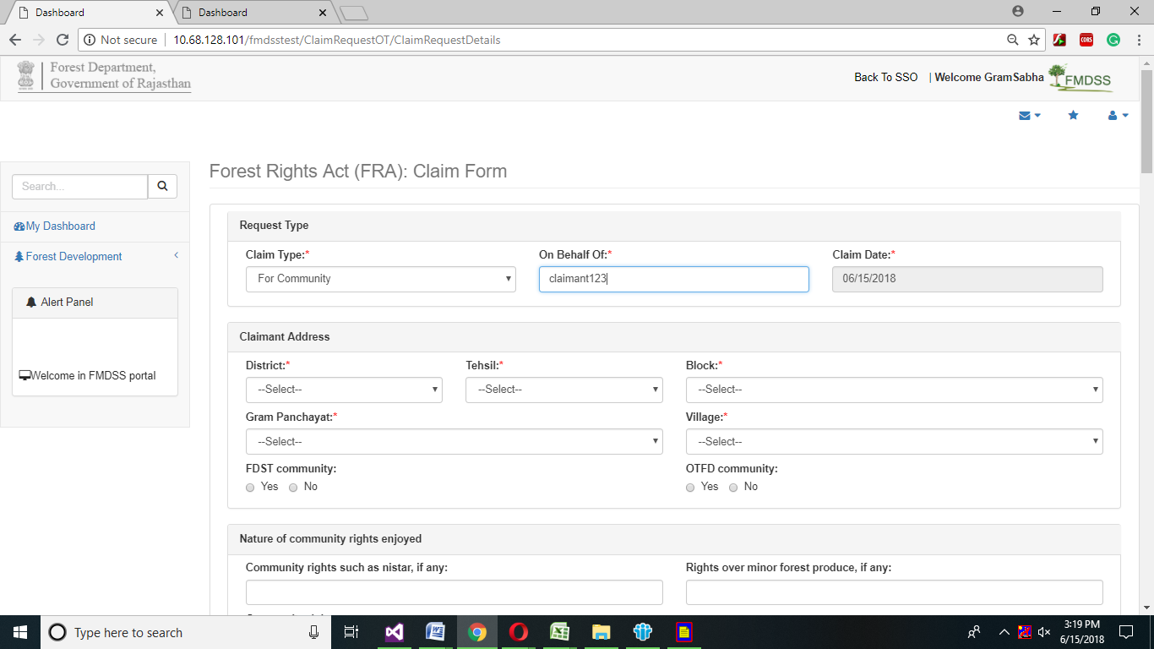

1. Gram Sabha user will enter Claimant address in Claimant address grid.



1. In Claimant Address grid, claimant will select the mandatory drop down.
2. Gram Sabha user will select Claimant District, Tehsil, Block, Gram Panchayat, and Village from the drop down menu
3. If claimant belongs to FDST Community then click on yes otherwise no similarly if claimant belongs to OTFD Community click on yes otherwise no.





1. In Nature of Right and Community grid claimant will enter if claimants have any above community rights, then claimant will enter will above highlighted field.



1. In Member of Gram Sabha grid, Gram Sabha user will enter Member Bhamashah id in member Bhamashah field and then click on Get Details button.



1. Gram Sabha user will select the Claimant member and click on Radio button.
2. Claimant family member information will automatically generated in mandatory fields
3. Gram Sabha user will click on Add Claimant details button claimant details will automatically generated in grid



1. Gram Sabha user will upload claimant member details evidence by clicking on choose button.



1. Gram Sabha user will enter Khasra No, Compartment No and Upload khasra/Compartment No evidence by clicking on choose button.



1. In bordering Village grid, Gram Sabha user will select claimant District name, Block name, Gram Panchayat name, Village name from the drop down menu.
2. Click on Add Bordering Village button all the Bordering village information will automatically generated in grid and then upload related documents by clicking on Choose Files button.

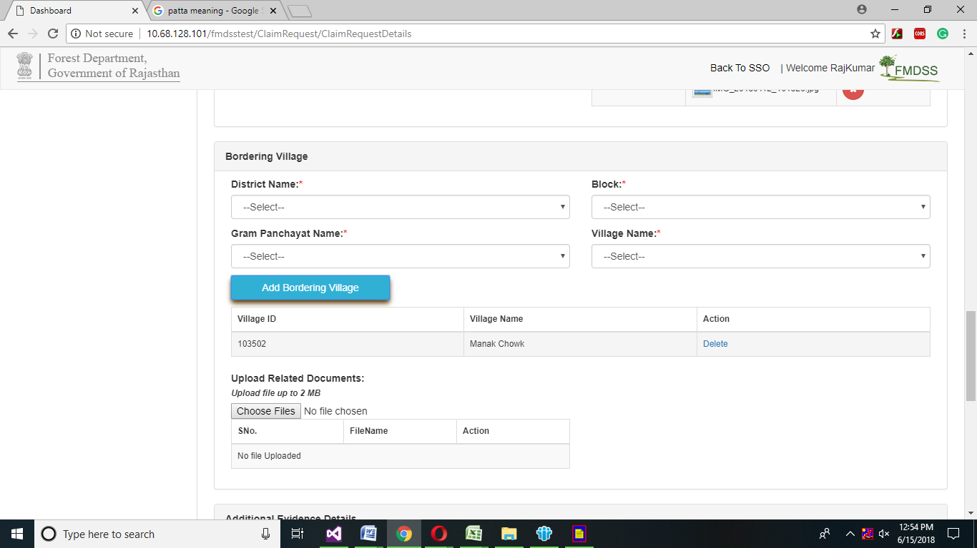

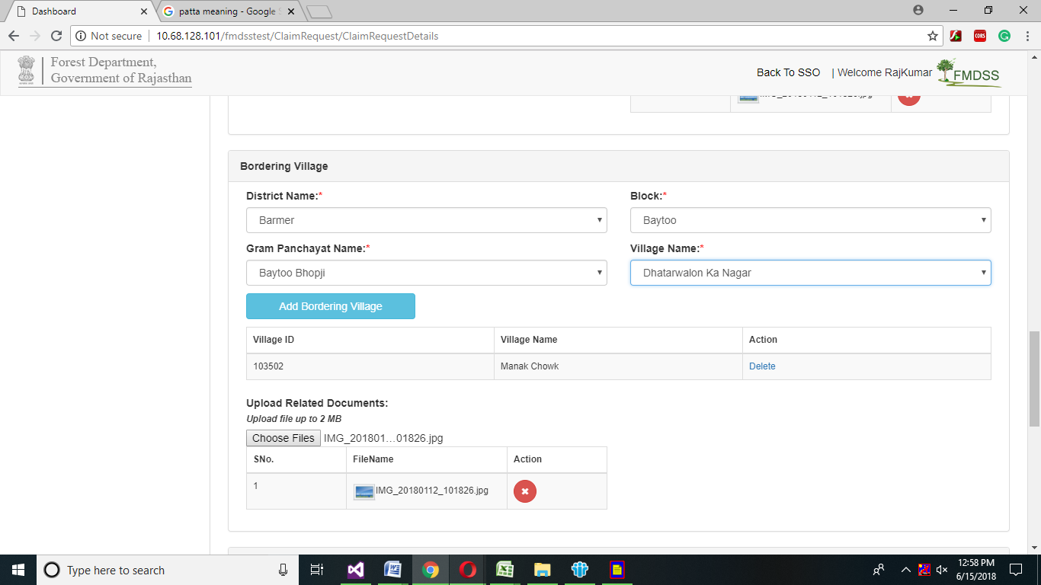

1. In Additional Evidence Details grid ,Gram Sabha user will select Evidence Type from the drop down menu and then selected evidence type claimant will upload by clicking on choose button.



1. In optional Details grid, Gram Sabha user can enter comment in comment text box.
2. In Approver Action, Gram Sabha user will enter Approver id in text box and also enter Approval Date and Comment and Case Number in given fields.



1. After entering all the necessary information click on save button.
2. If Gram Sabha user wants to reset any information, then click on reset button.
3. If Gram Sabha user want to cancel the form, then click on cancel button.

# 3.3 User Registration for forest Right Act

1. User will click on FRA Registration and then click on Add New User.

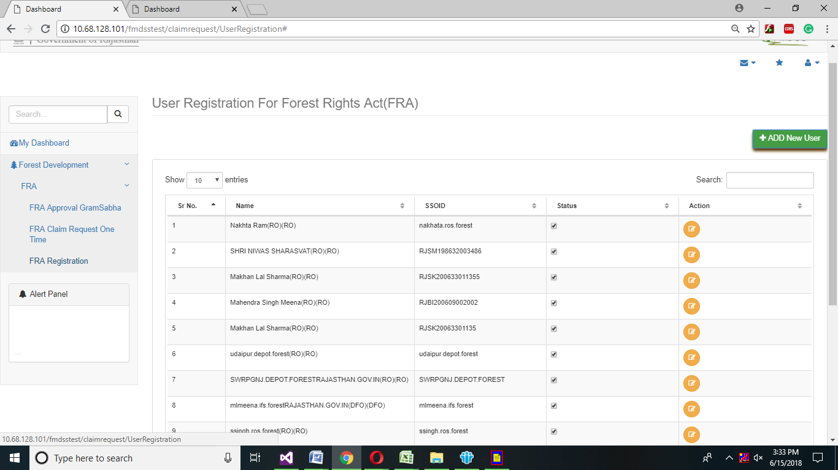

1. Gram Sabha user will enter User sso id in sso id field ,Name of user in name field, select District ,Tehsil, Block , Gram Panchayat ,Village of user from the drop down menu .
2. Enter Email ID, Mobile No, Bhamashah Id, Aadhar id in given field.
3. Select Role from the drop down menu.
4. Select Date of Birth from the calendar.
5. Select Gender from the drop down menu.
6. Enter Postal address, Postal Code, in given field.
7. Select Active/Deactivate from the drop down menu.

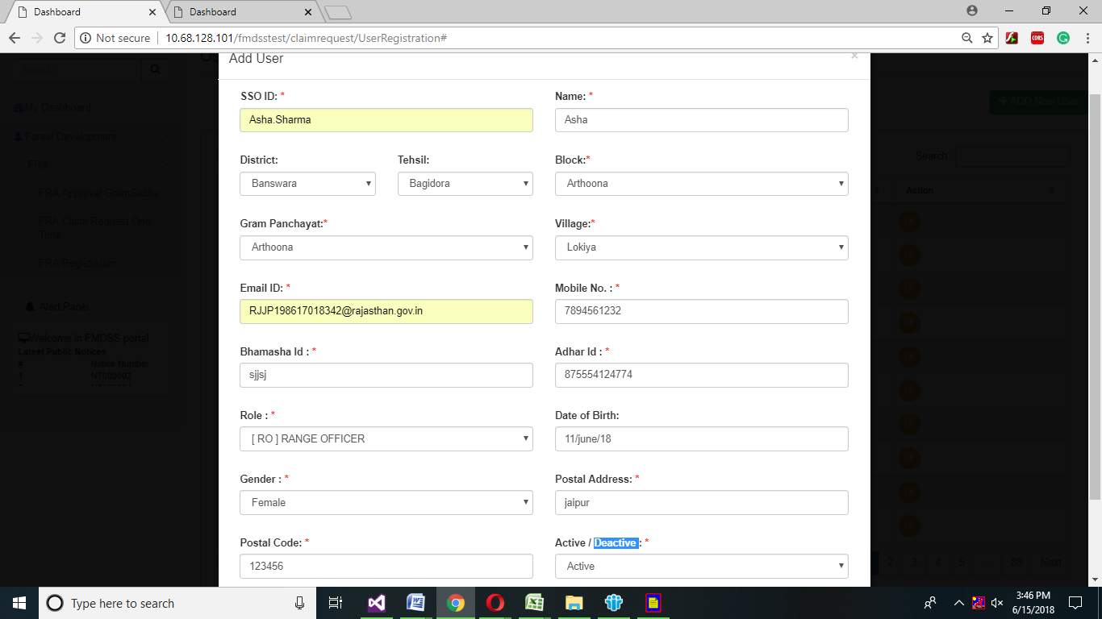

1. Click on save button.

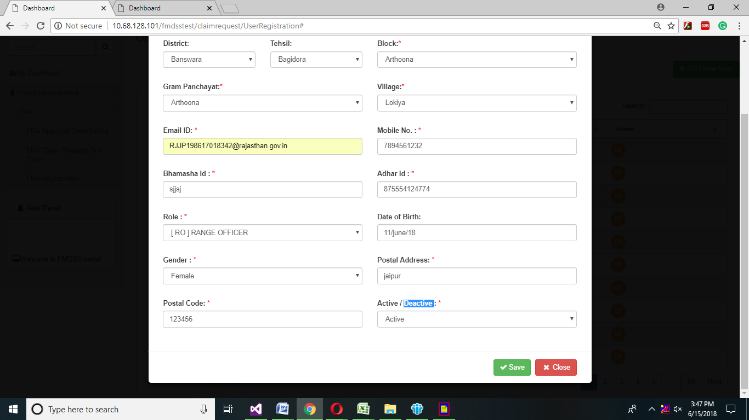

# Range Officer Module

1. Range officer will login in SSO using Sso id and password.

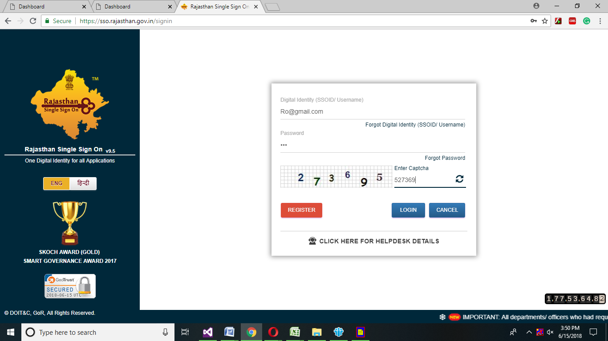

1. Range officer dashboard will open ,click on Forest development->FRA->FRA Approval process SDLC.

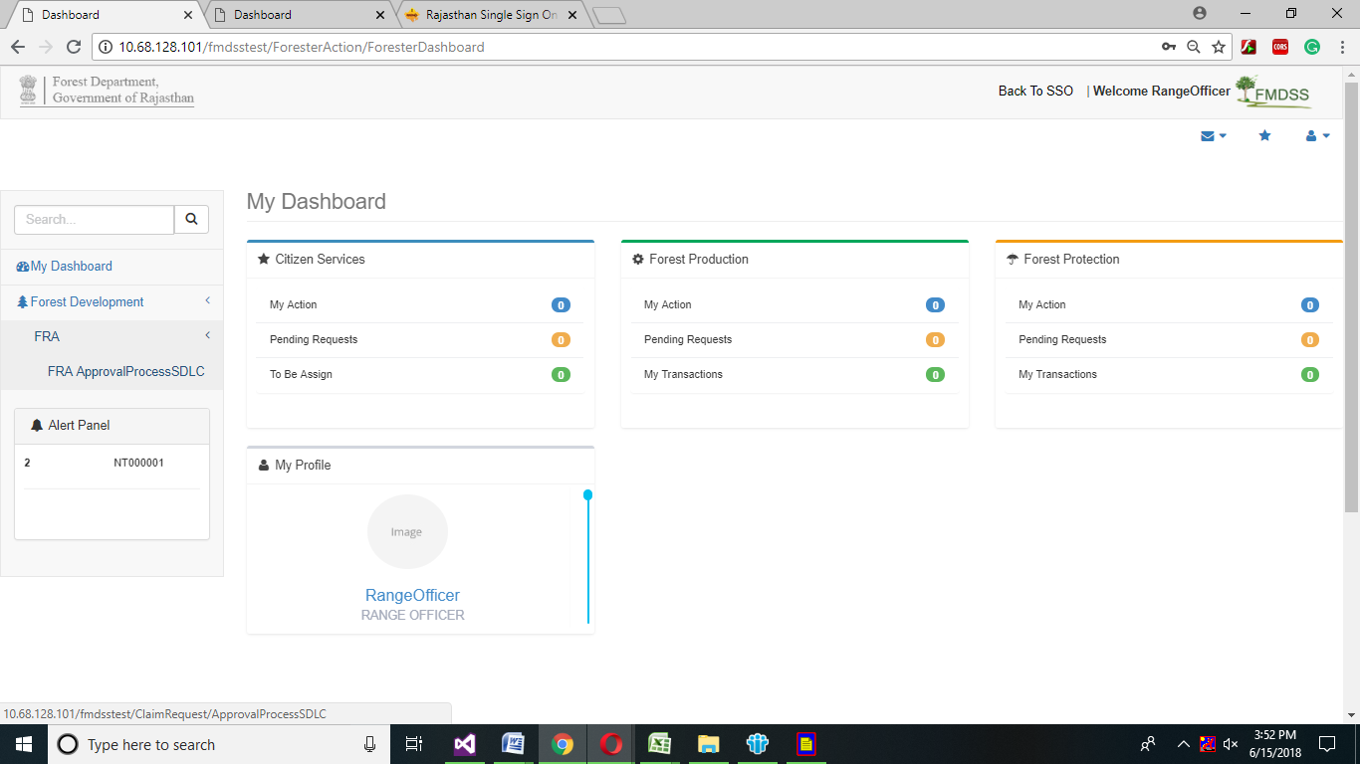

1. Click on View Survey Details
2. After viewing Applicant Details, click on close button.

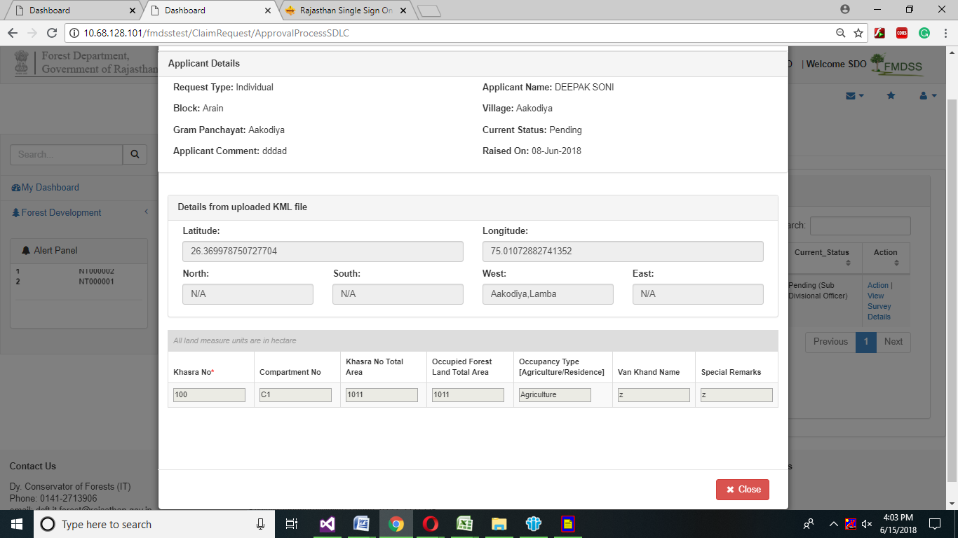

1. Click on Action link in Action grid.

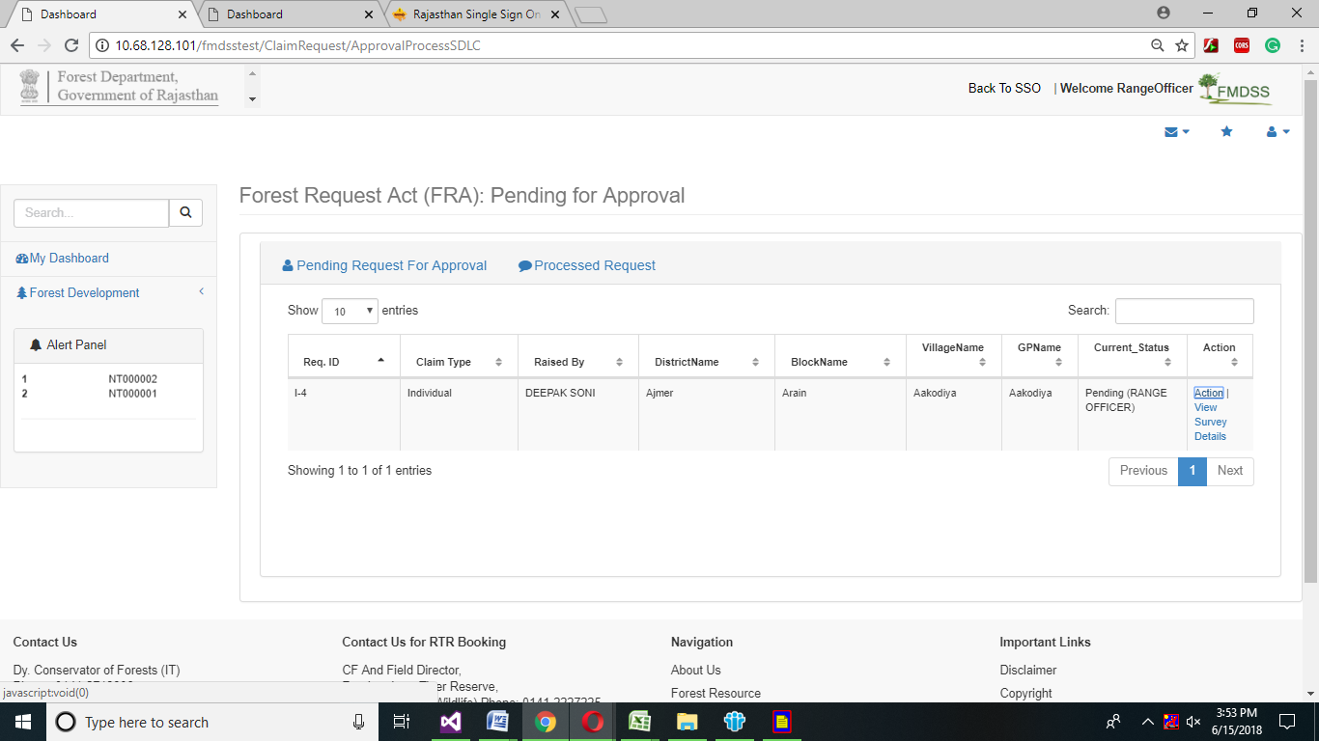

1. Detail of Claimant page will open, Select Action from the drop down menu and enter Remark in Remark Text box.
2. If Range officer select Reject from the drop down menu then Reason drop down menu will be appear.
3. Select appropriate reason of rejection from the drop down menu and click on submit button.

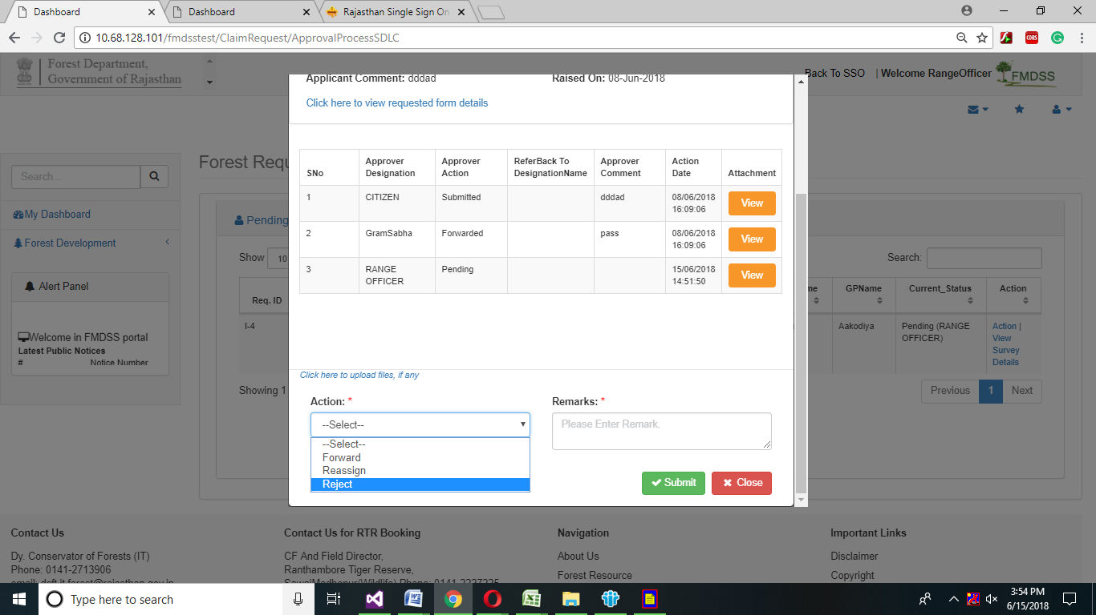

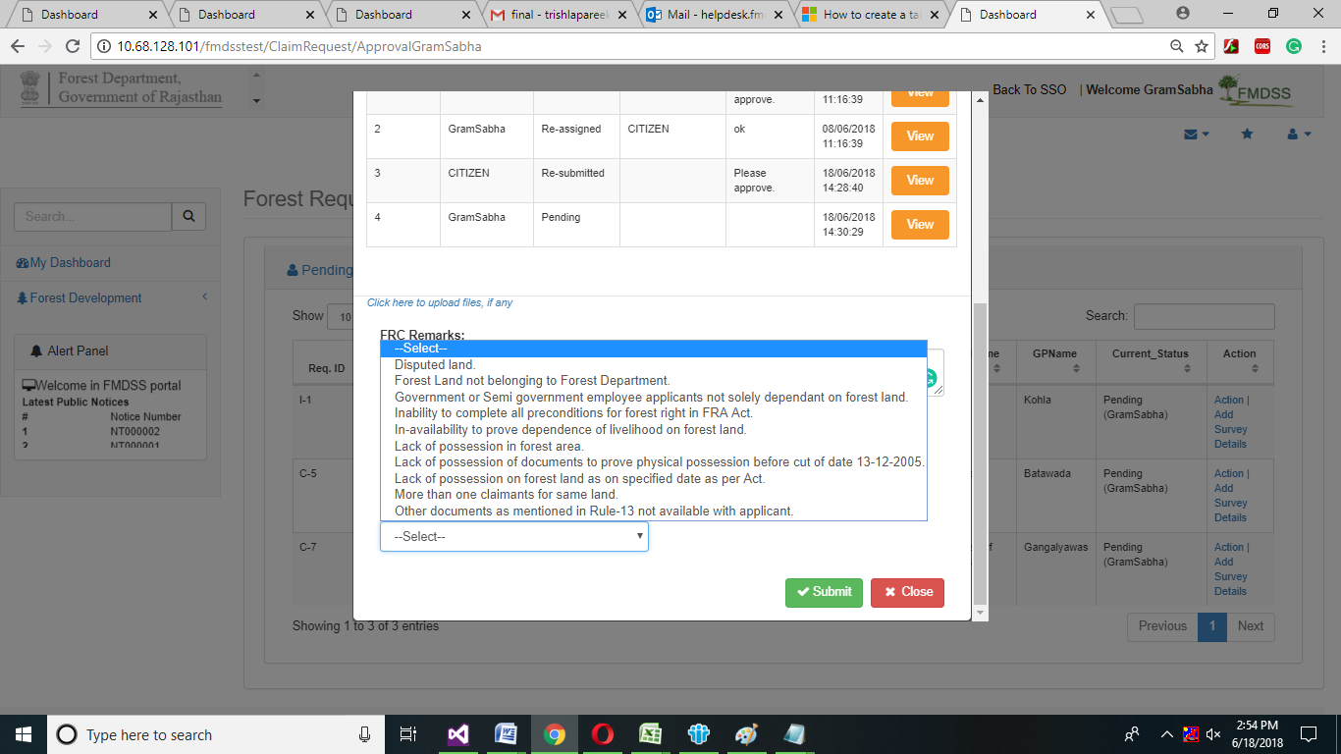

1. If Range officer want to reassign the request of citizen, then select reassign from the drop down menu.
2. If Range wants to forward the request, select forward option from the drop down menu.
3. Click on Submit button.

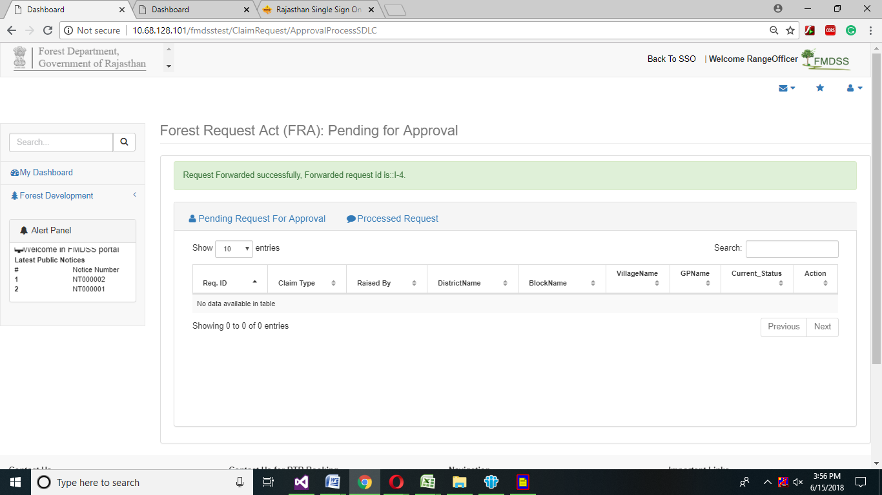

# Sub Divisional Officer

1. Sub Divisional officer will login in Sso using Sso id and password.

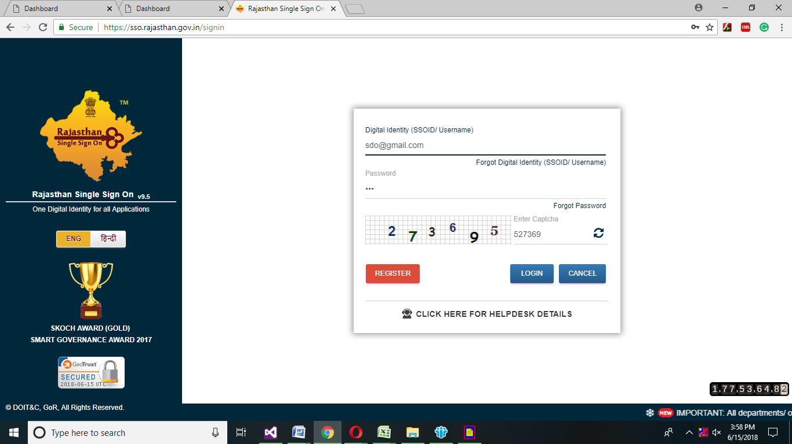

1. Sub Divisional officer dashboard will open, click on Forest development->FRA->FRA Approval process SDLC.

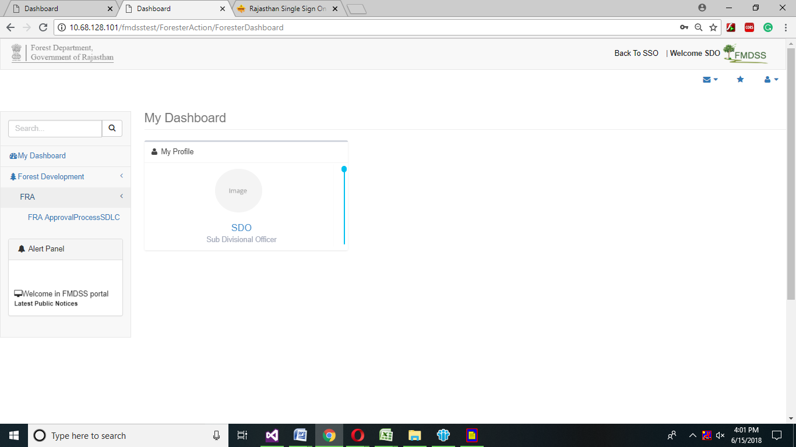

1. Click on Survey Details in Action grid.

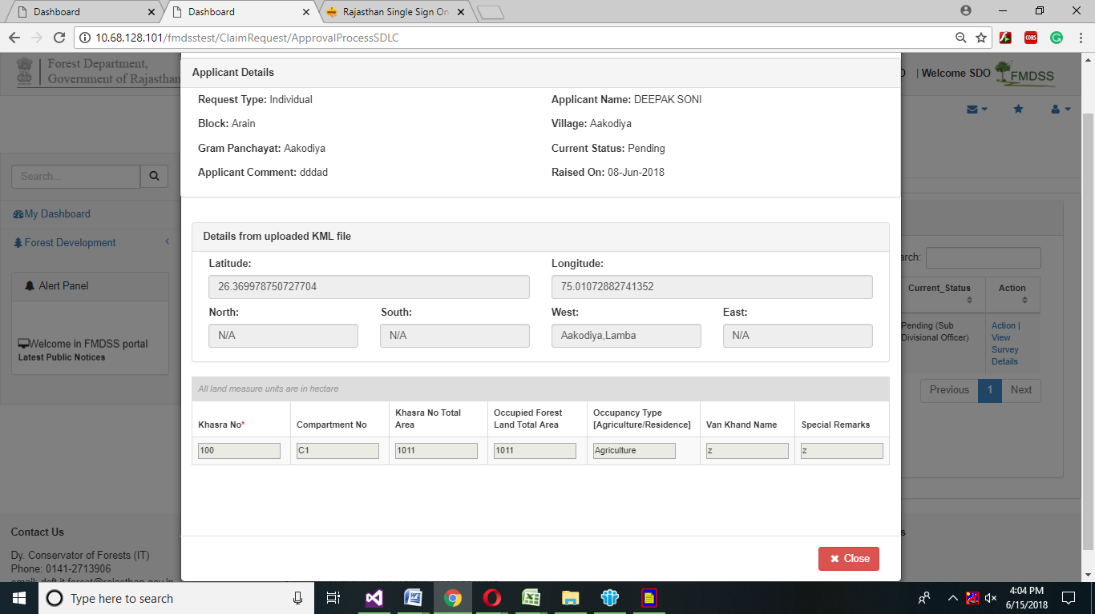

1. After Viewing the Details of Applicant, click on close button.
2. Click on Action in Action grid.
3. In Details of claimant, Select Action from the drop down menu and enter Remark in remark text box.
4. If Sub -Divisional officer select Reject from the drop down menu then Reason drop down menu will be appear.
5. Select appropriate reason of rejection from the drop down menu and click on submit button.





1. If Sub -Divisional officer want to reassign the request of citizen, then select reassign from the drop down menu.
2. If Sub -Divisional wants to forward the request, select forward option from the drop down menu.

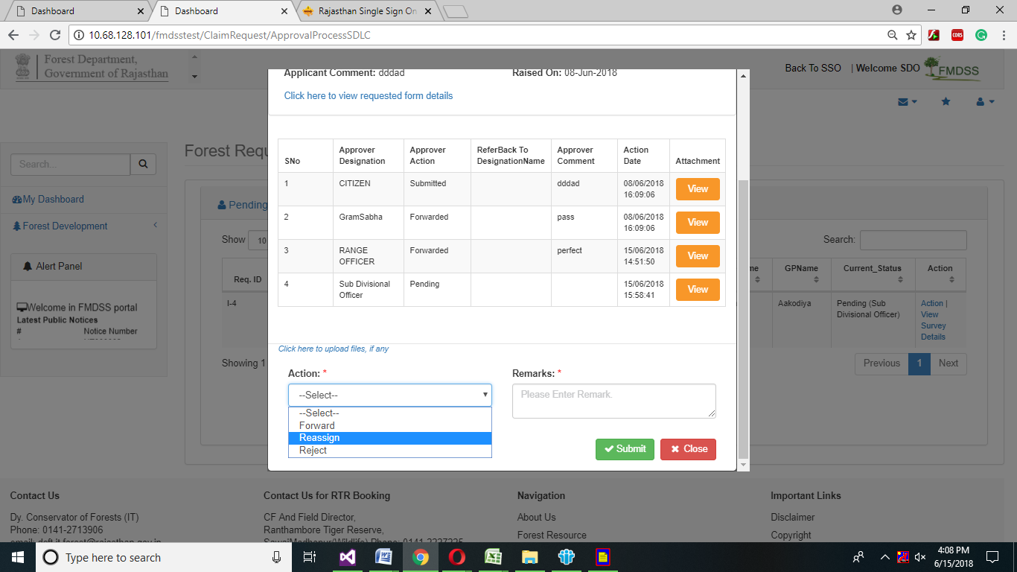

1. Click on Submit Button.

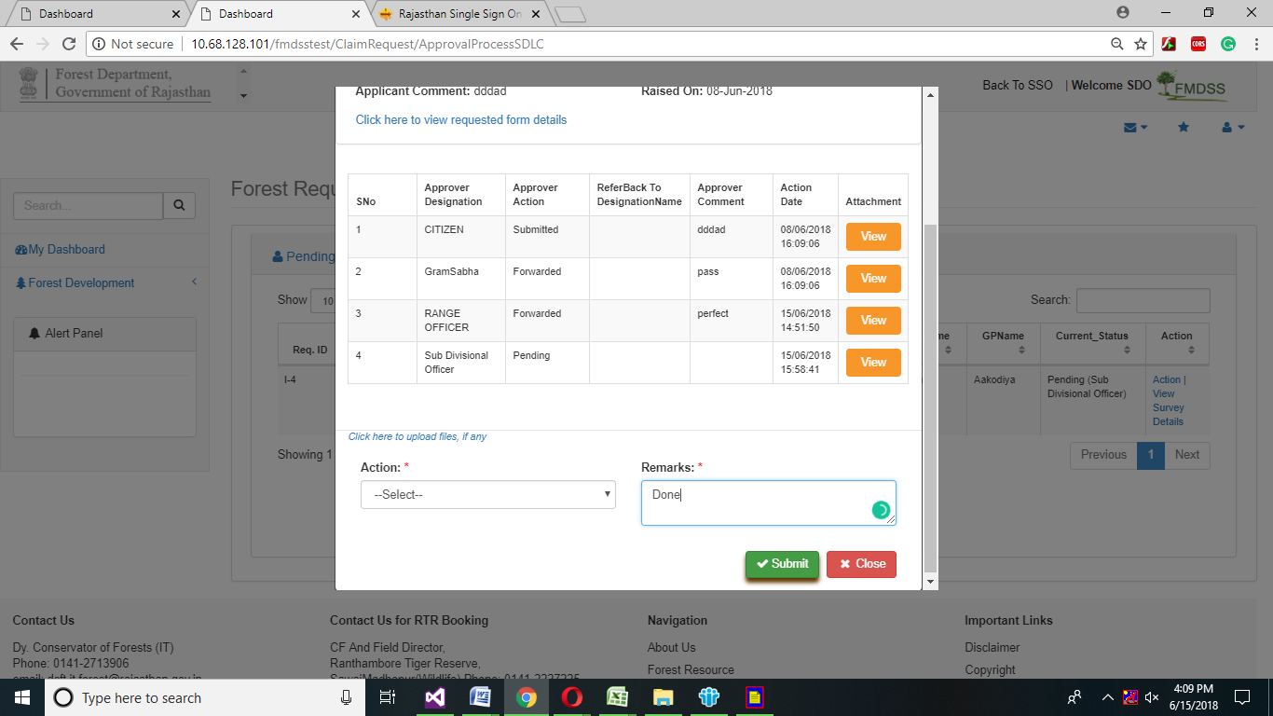

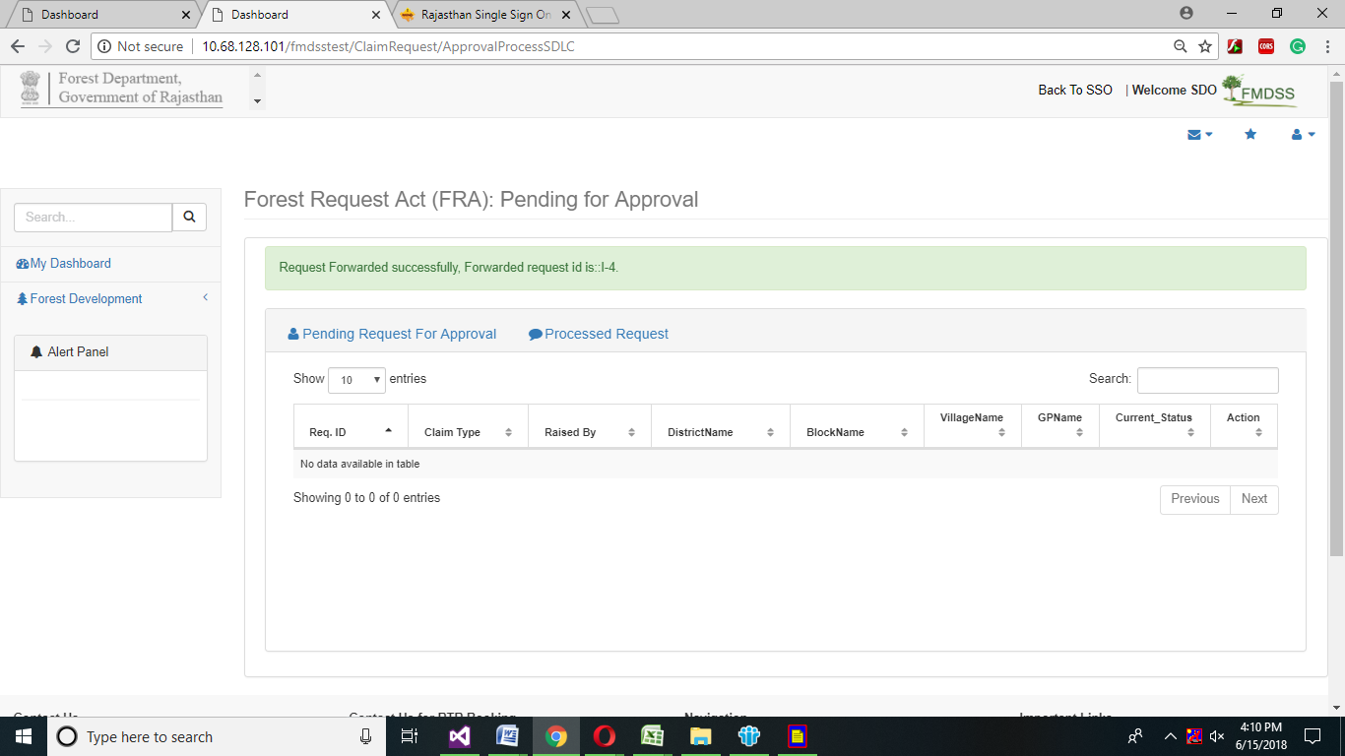

# Divisional Forest officer

1. Divisional Forest officer will login in SSO using SSO id and password.

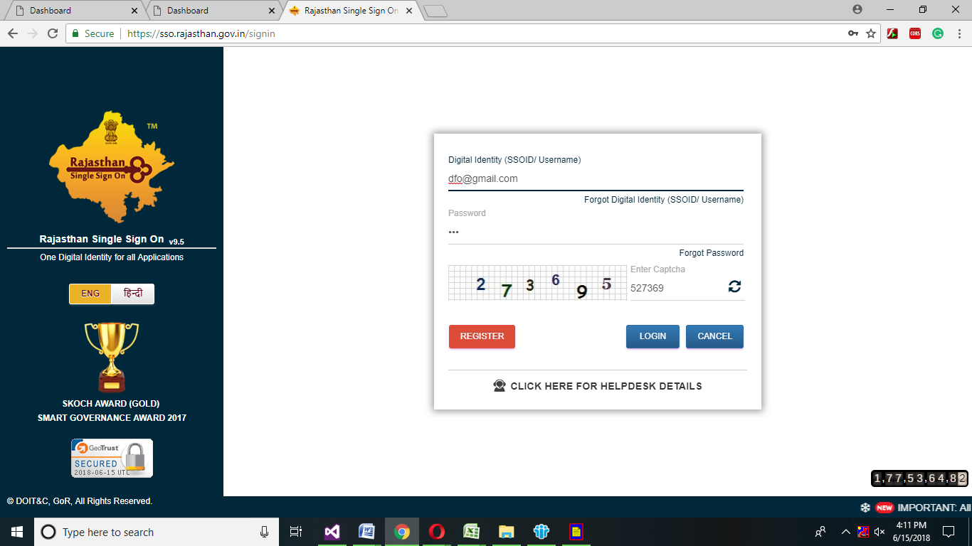

1. Divisional Forest officer dashboard will open, and then click on Forest development->FRA->FRA Approval process SDLC.

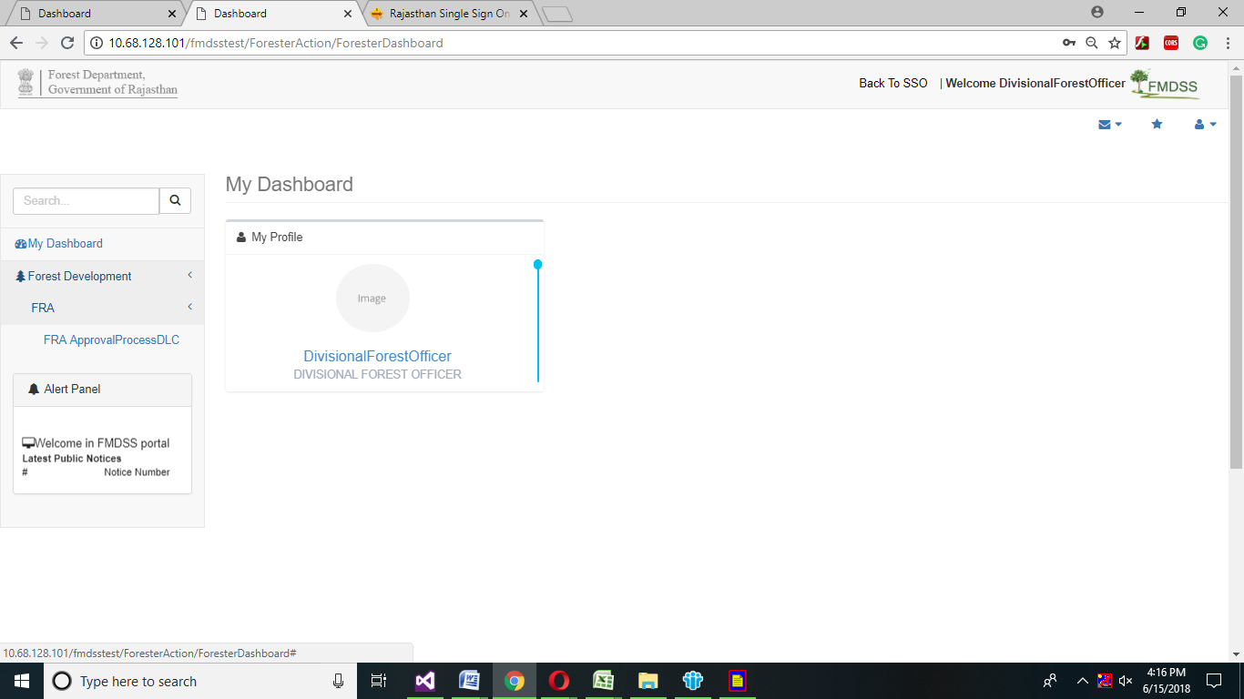

1. Click on Survey Details in Action grid.



1. After Viewing the Details of Applicant click on close button.
2. Click on Action link in Action grid.
3. In Details of claimant, Select Action from the drop down menu and enter Remark in remark text box.
4. If Divisional Officer wants to reject the request of citizen, then select reject option from the drop down.





1. If Divisional officer want to reassign the request of citizen, then select reassign from the drop down menu.
2. If Divisional wants to forward the request, select forward option from the drop down menu.



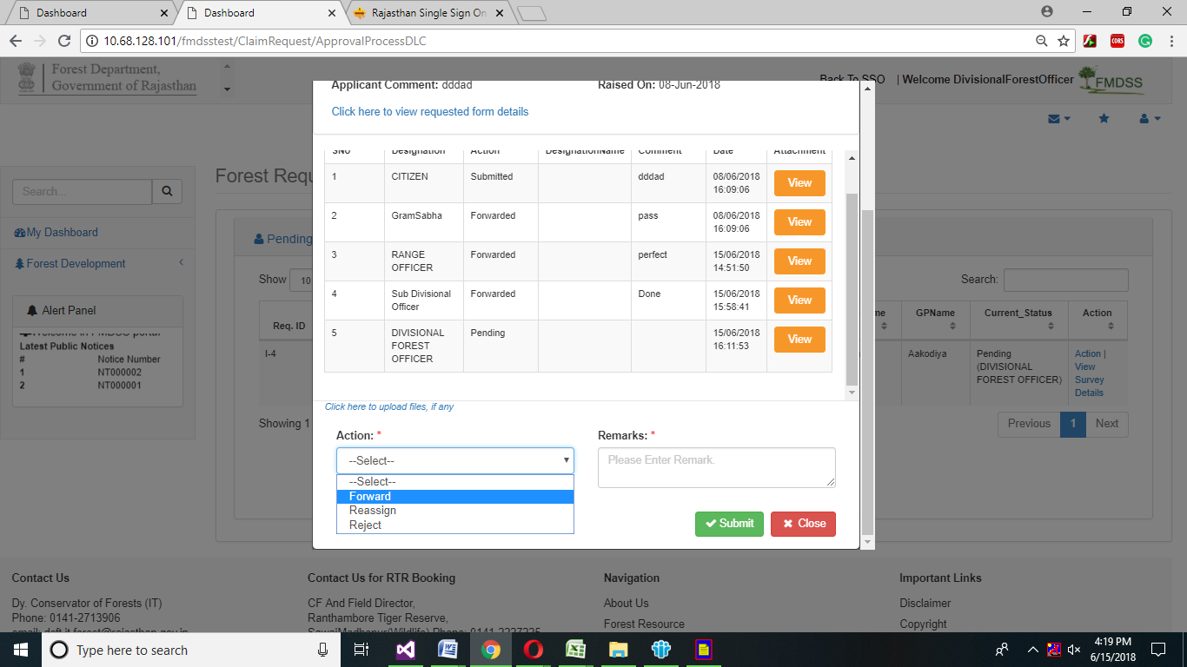

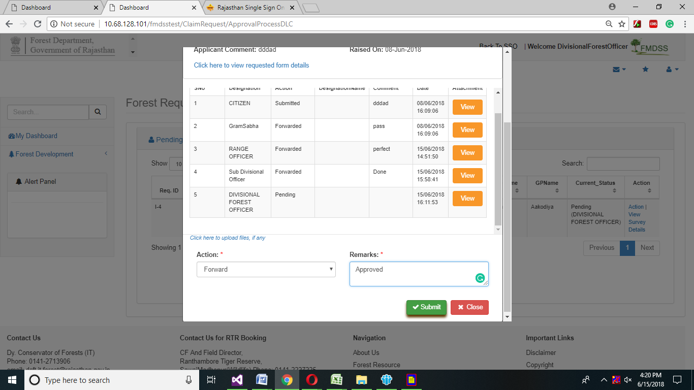

1. Click on Submit button.

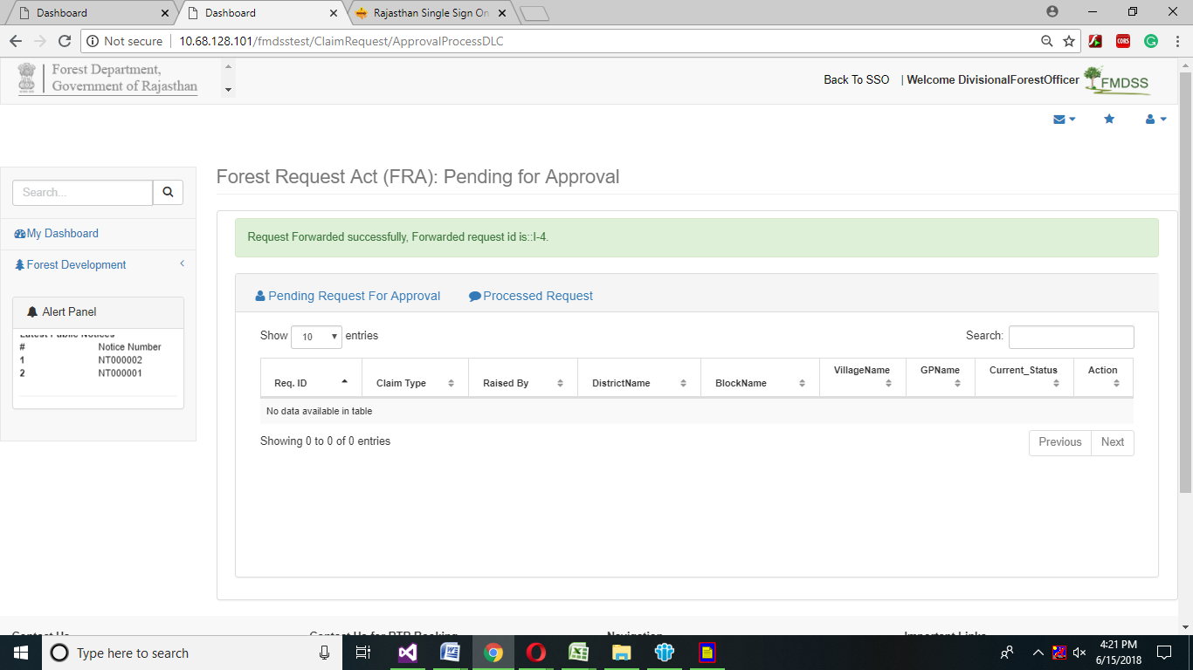

# Tribal Area Development

1. Tribal Area Development officer will login in SSO using Sso id and password.

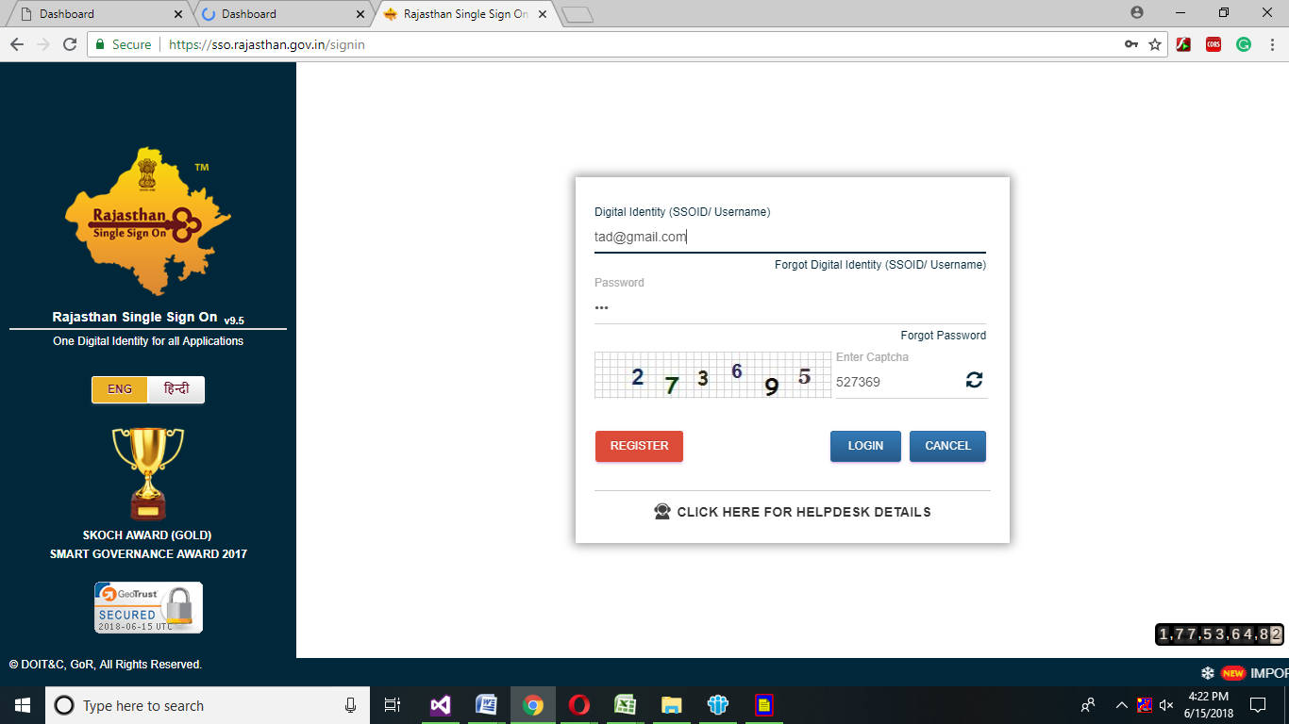

1. Tribal Area Development officer dashboard will open, and then click on Forest development->FRA->FRA Approval process SDLC.

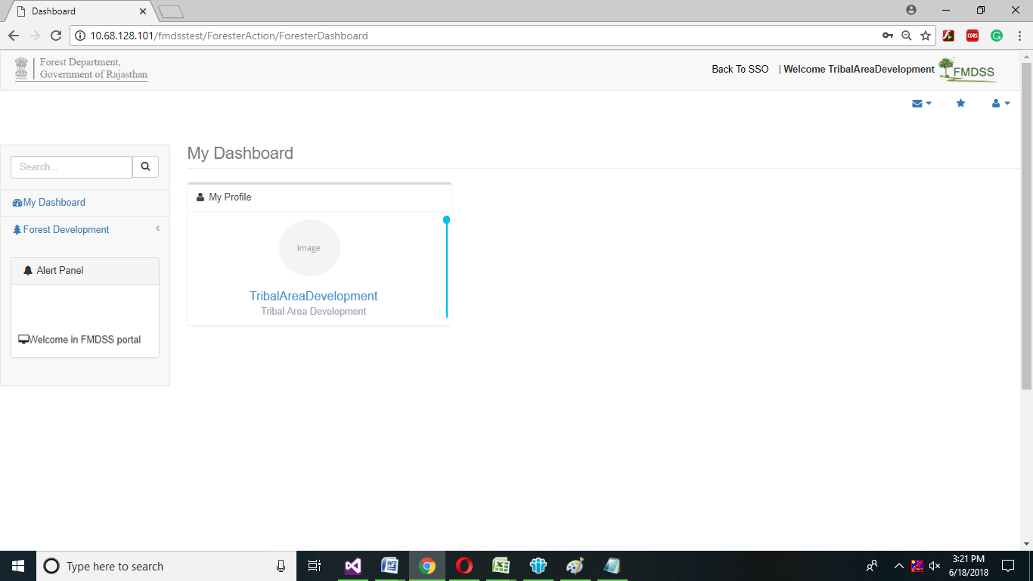

1. Click on Survey Details in Action grid.

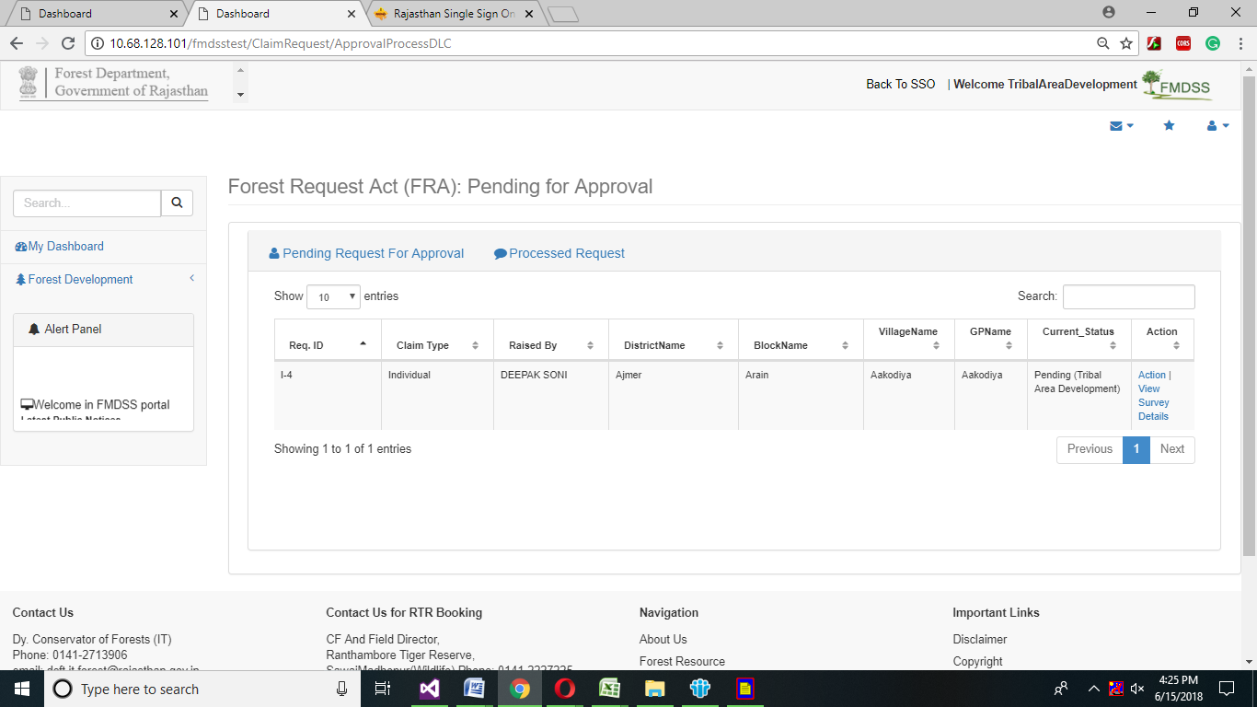



1. After Viewing the Details of Applicant, click on close button.
2. Click on Action link in Action grid.

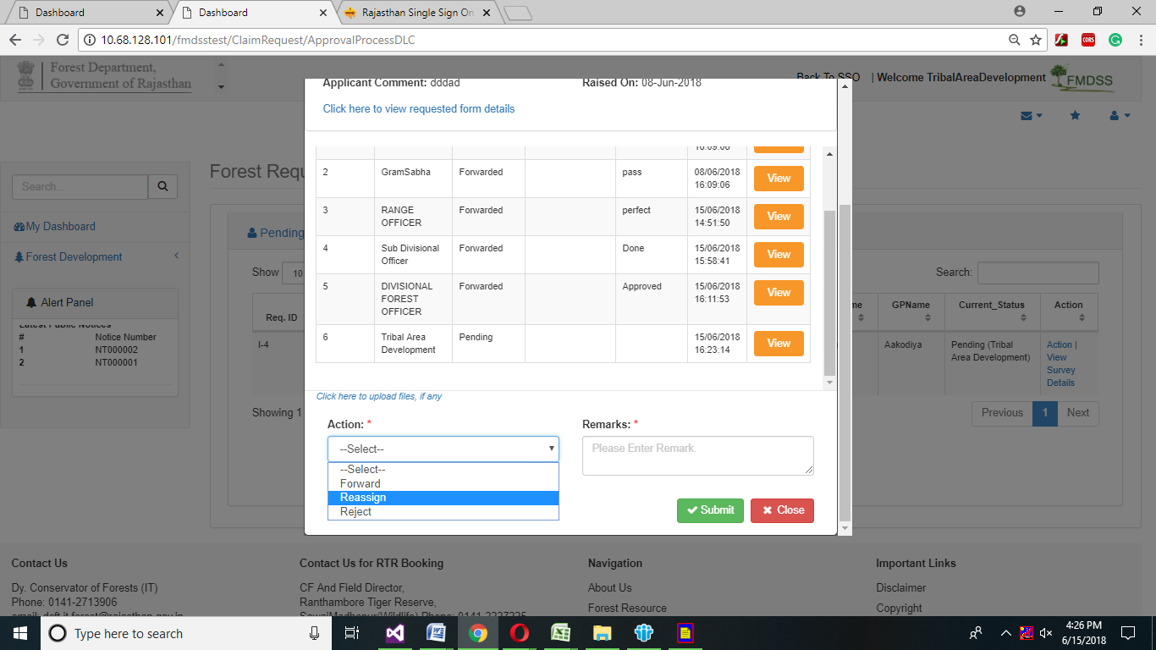

1. In Details of claimant, Select Action from the drop down menu and enter Remark in remark text box.
2. If tribal area development officer wants to reject the request of citizen, then select reject option from the drop down.





1. If tribal area development officer want to reassign the request of citizen, then select reassign from the drop down menu.
2. If tribal area development officer wants to forward the request, select forward option from the drop down menu.

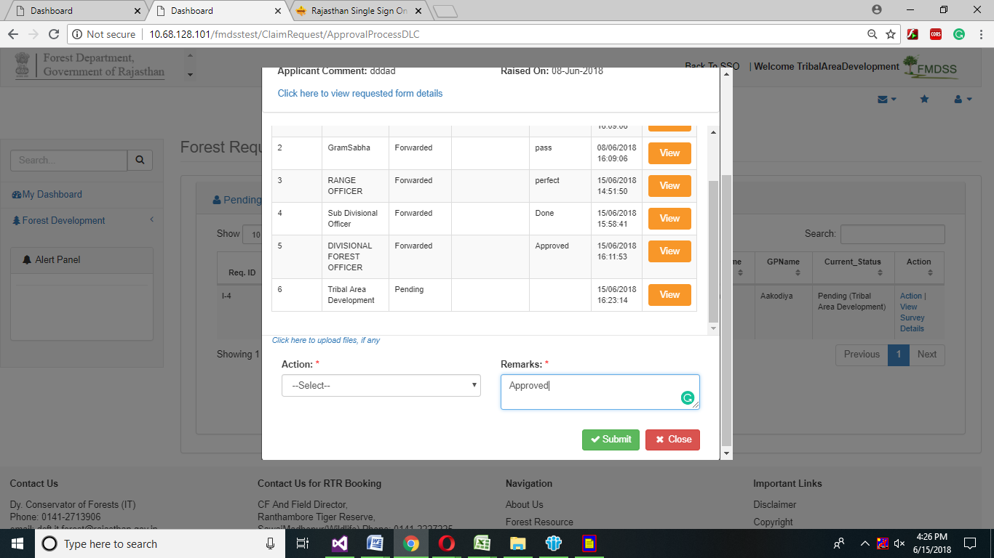

1. Click on Submit button.

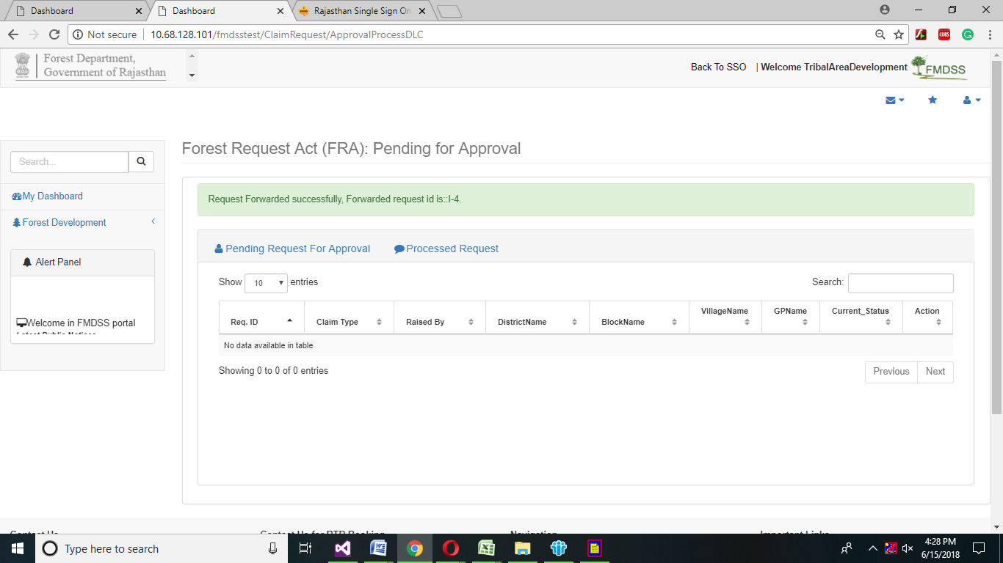

# Collector

1. Collector will login in sso using sso id and password.

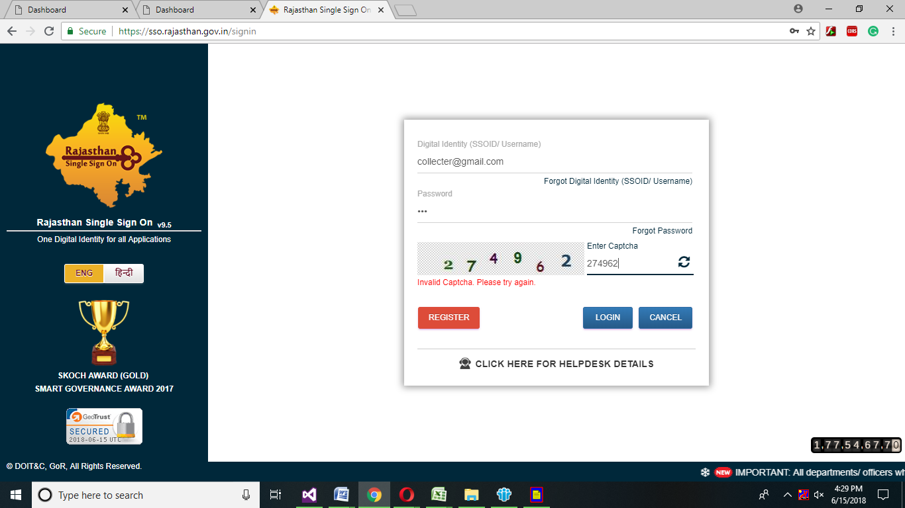

1. Collector dashboard will open, and then click on Forest development->FRA->FRA Approval process Final.

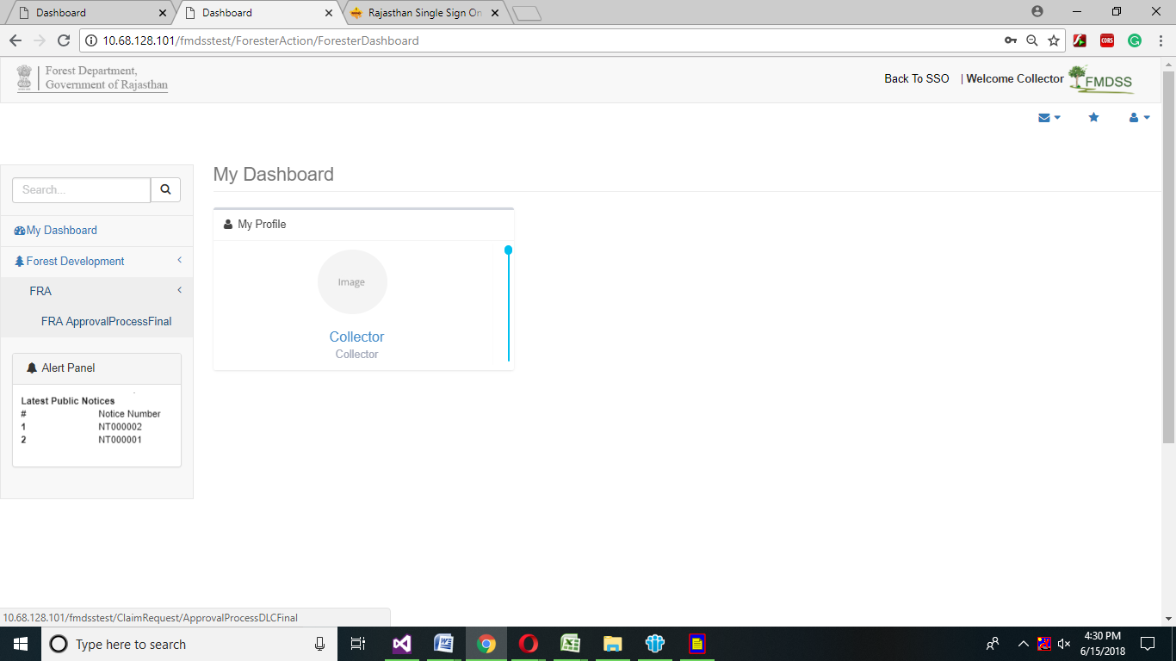

1. Click on View Survey Details.

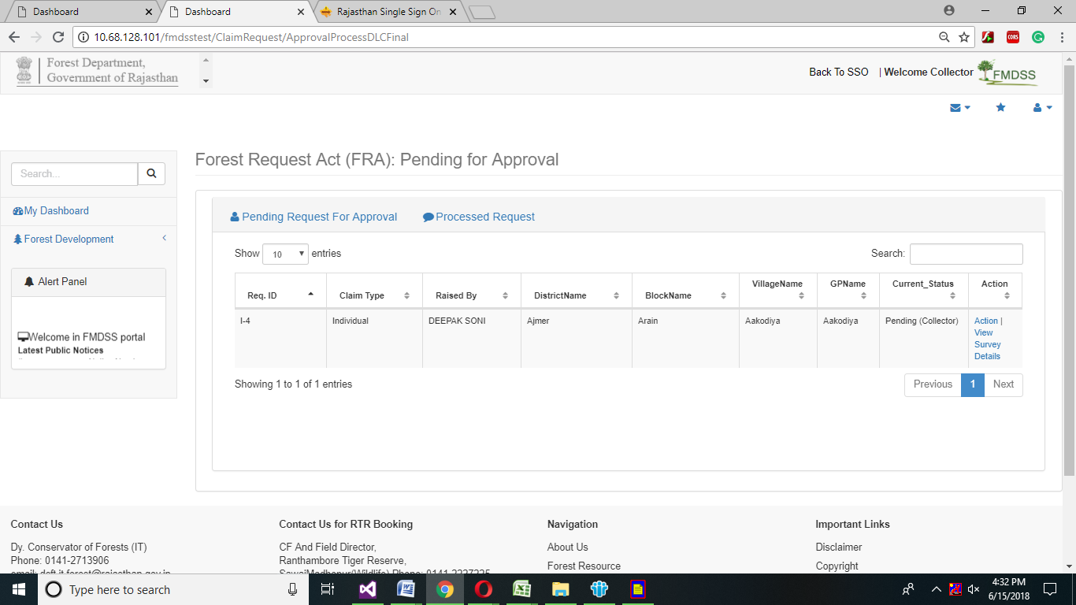



1. After Viewing the Details of Applicant, click on close button.
2. Click on Action button in Action Grid.
3. Select Action from the drop down menu.
4. Enter remark in remark text box.
5. If Collector wants to reject the request of citizen, then select reject option from the drop down.



1. After selecting reject option from the drop down menu, reason drop down menu will appear select appropriate reason of rejecting citizen request from the drop down menu.



1. If collector wants to reassign the request of citizen, then select reassign from the drop down menu.
2. If collector wants to forward the request, select forward option from the drop down menu.

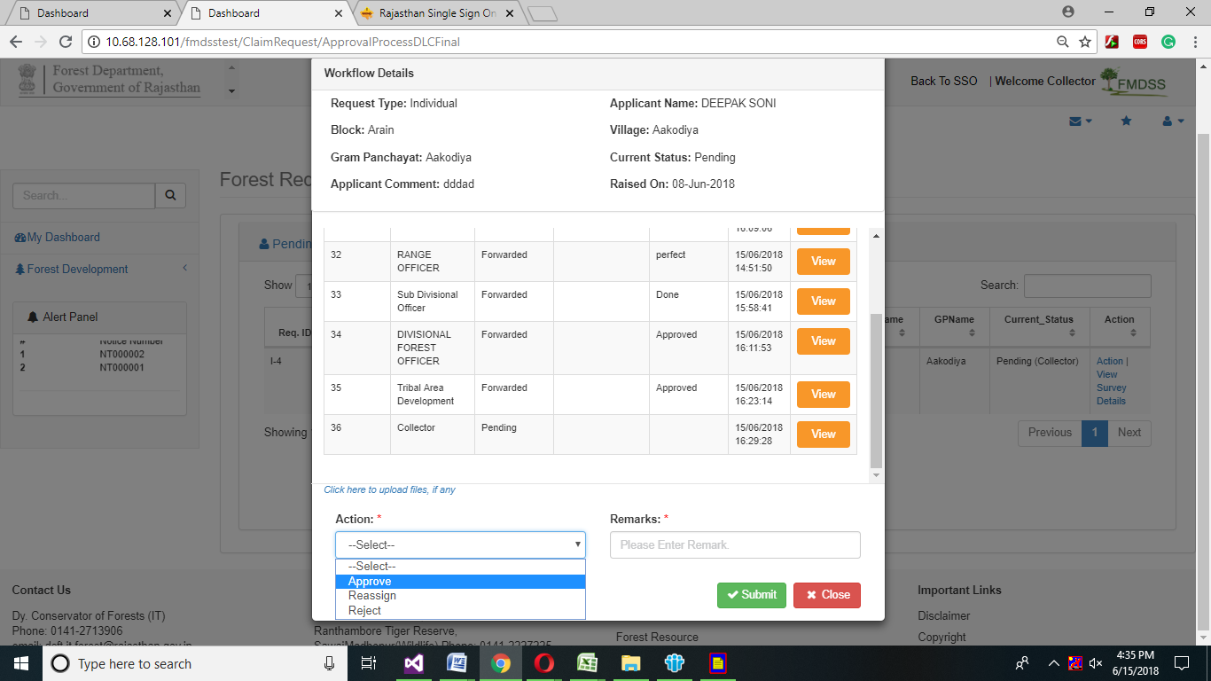

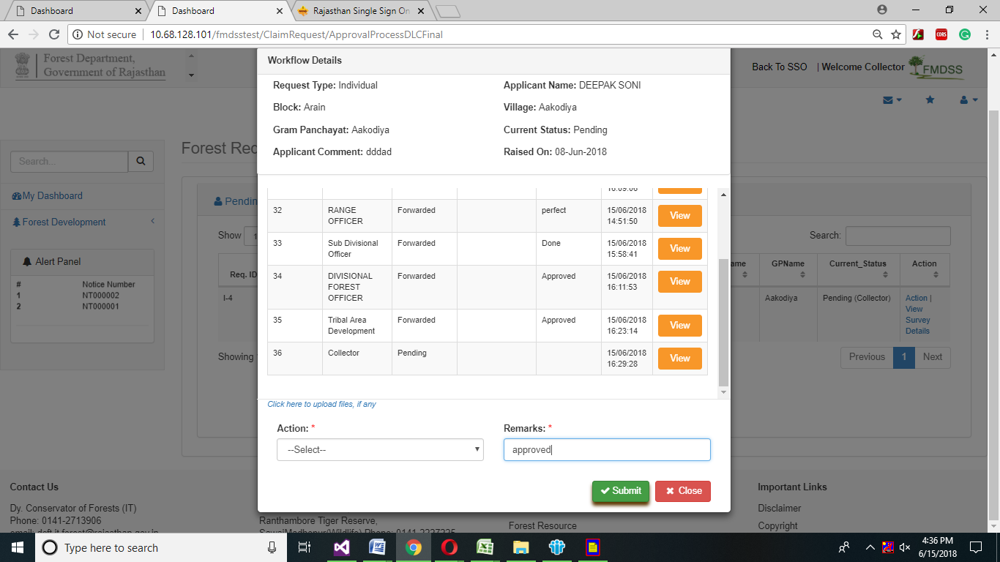

1. Click on Submit button.
2. Enter Valid OTP no which appear on verified mobile number and click on Confirm button.

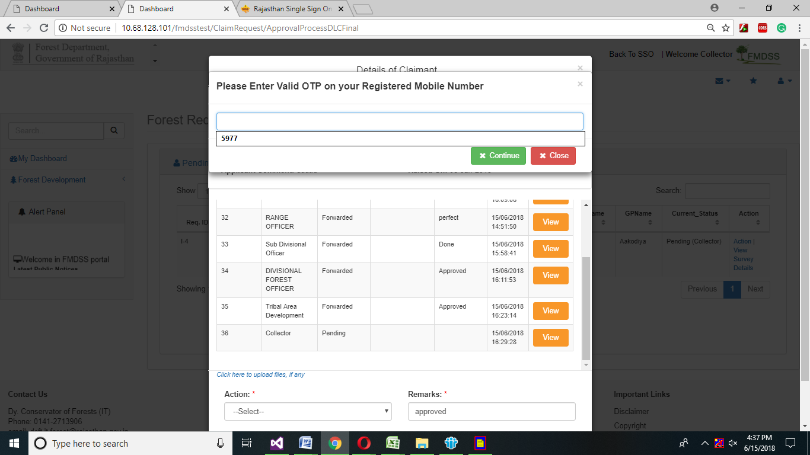

Note: - Citizen Request will finally approve successfully.

